AWS VPC

1. Open AWS console <https://console.aws.amazon.com/console/home?region=us-east-1>

2. Select VPC from *Networking Section*

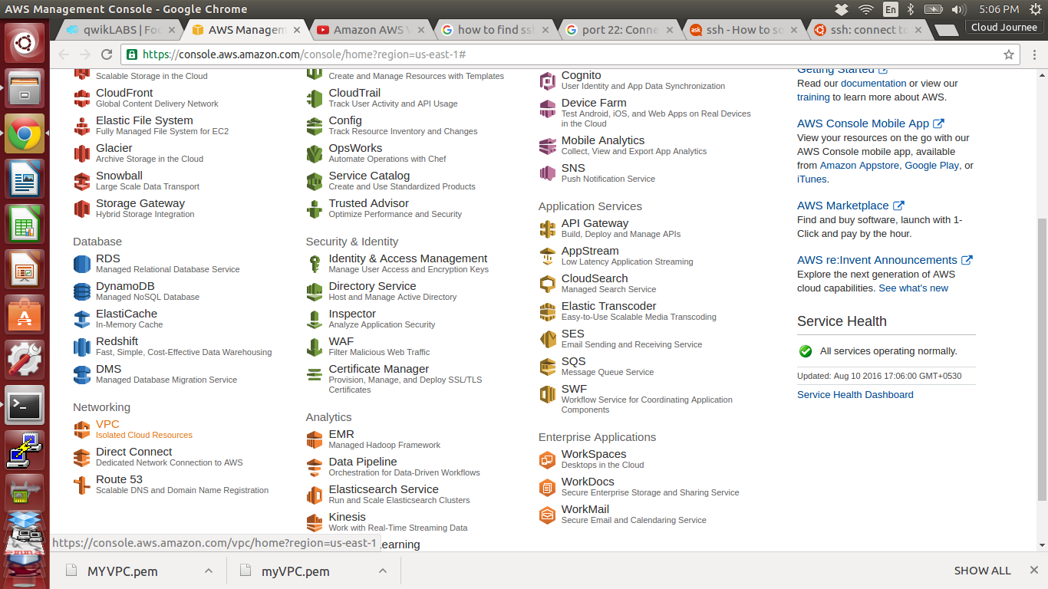

3. Click Start VPC

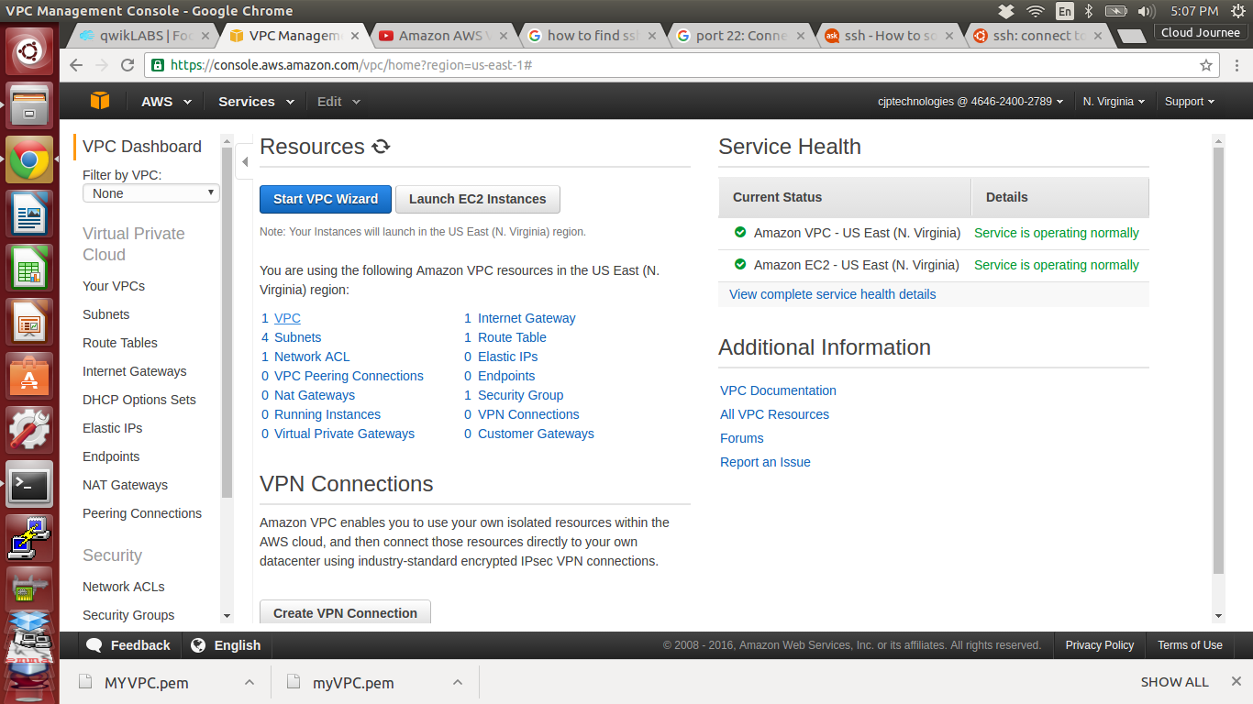

4. Create VPC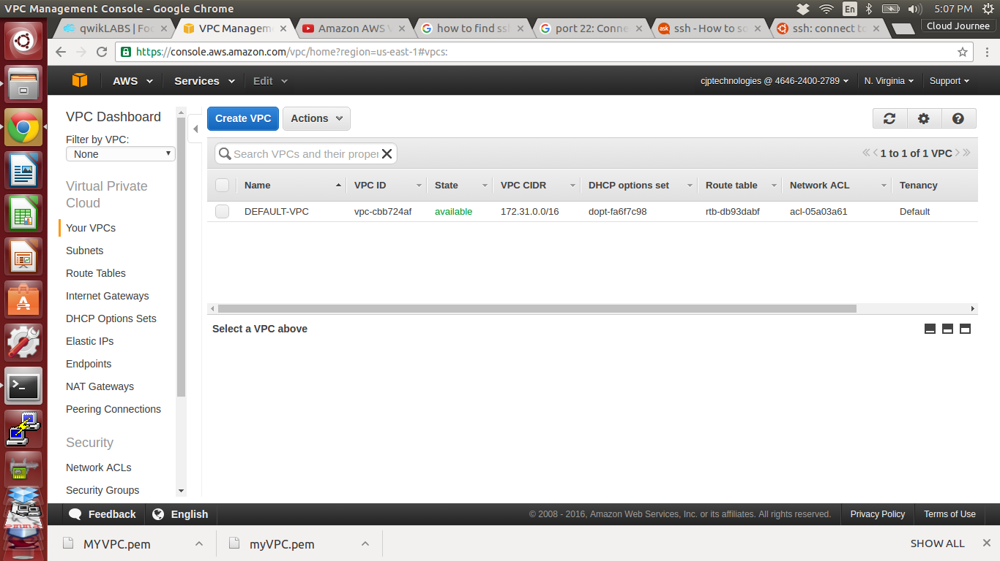



5. Assigin Name and CIDR block

Name tag : MYVPC ( name of our VPC )

CIDR block :192.168.0.0/16 ( IP range of our VPC )

6. Click Yes create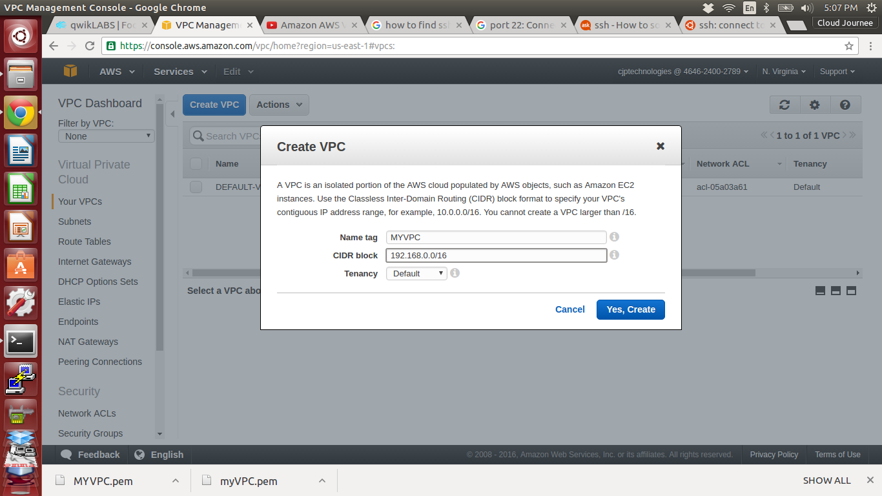



7. Our MYVPC is Created

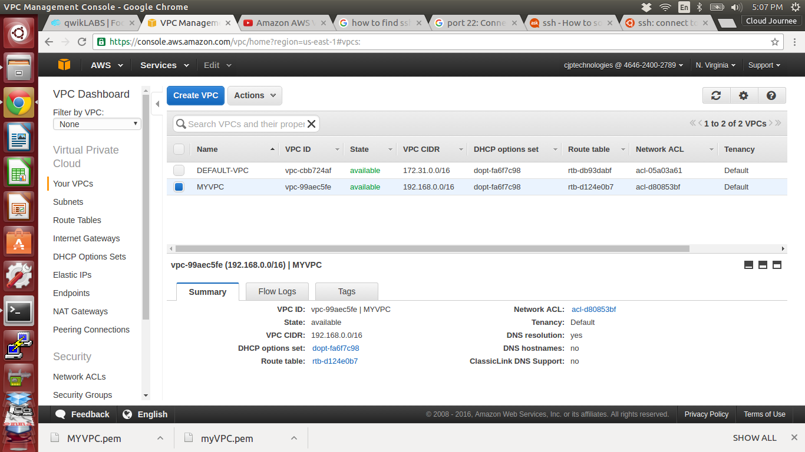

8. Go to *Subnets* under VPC on left tab, and click Create Subnet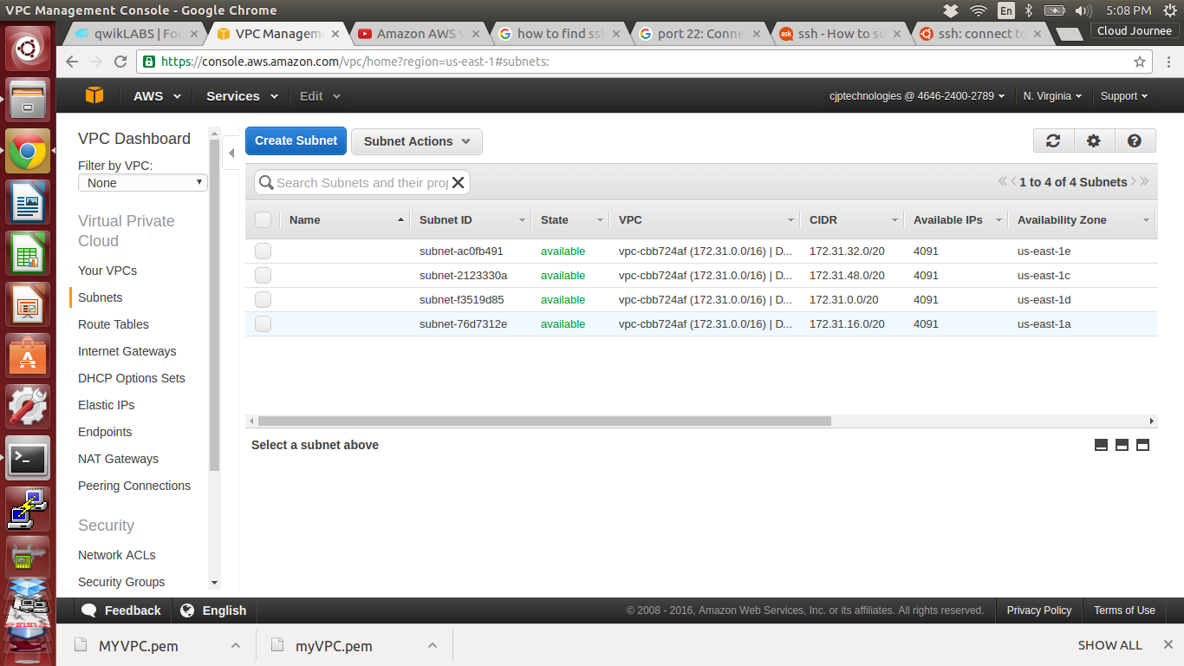



9. Name the subnet and choose our VPC and assign CIDR block for Subnet

Name : Public-sub

VPC : MYVPC

CIDR block : 192.168.1.0/24

10. Click yes create

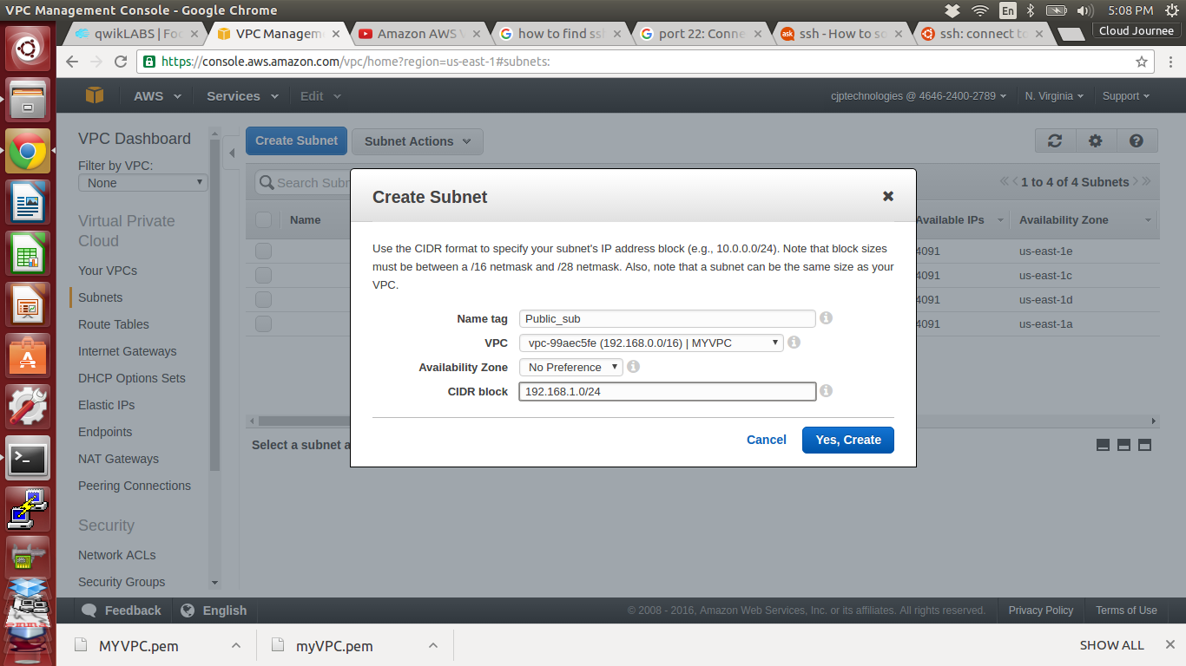

11. Public Subnet created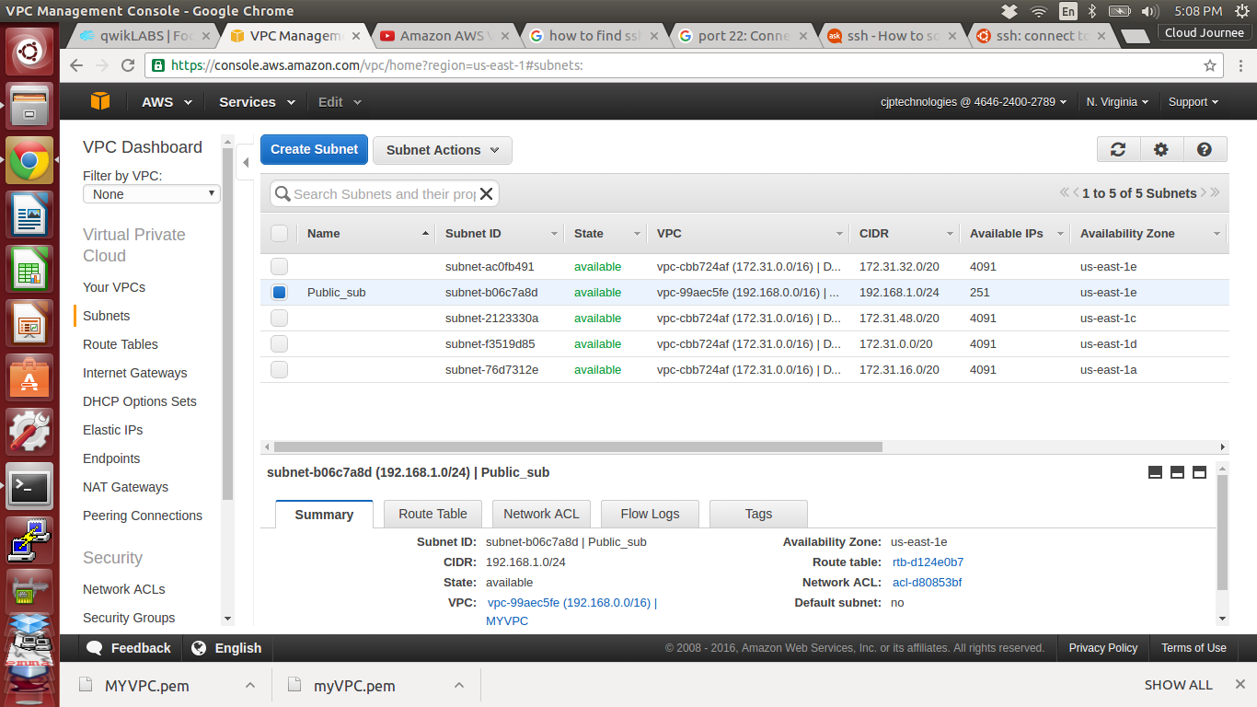



12. Create another Subnet as Private_sub

Name : Private_sub

VPC : MYVPC

CIDR block : 192.168.2.0/24

13. Click Yes create

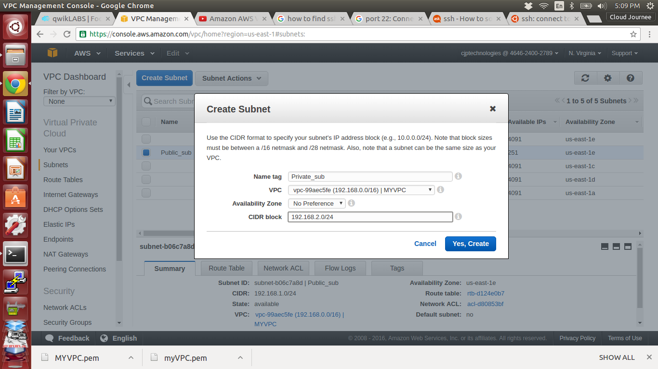

14. Private subnet is Created

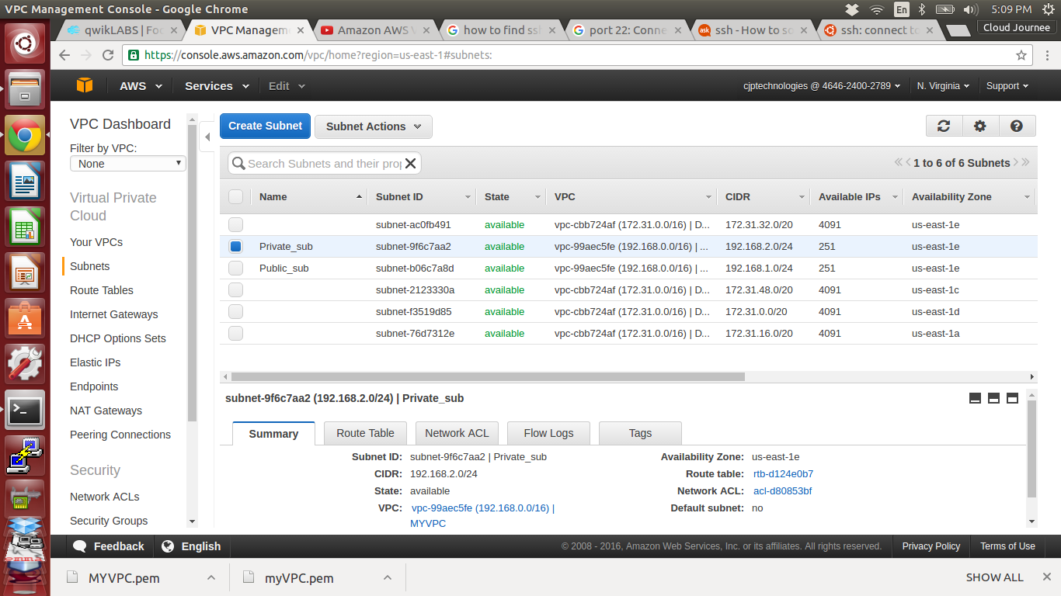

15. Go to *Route Tables* under VPC on left tab, and click Create Route Table

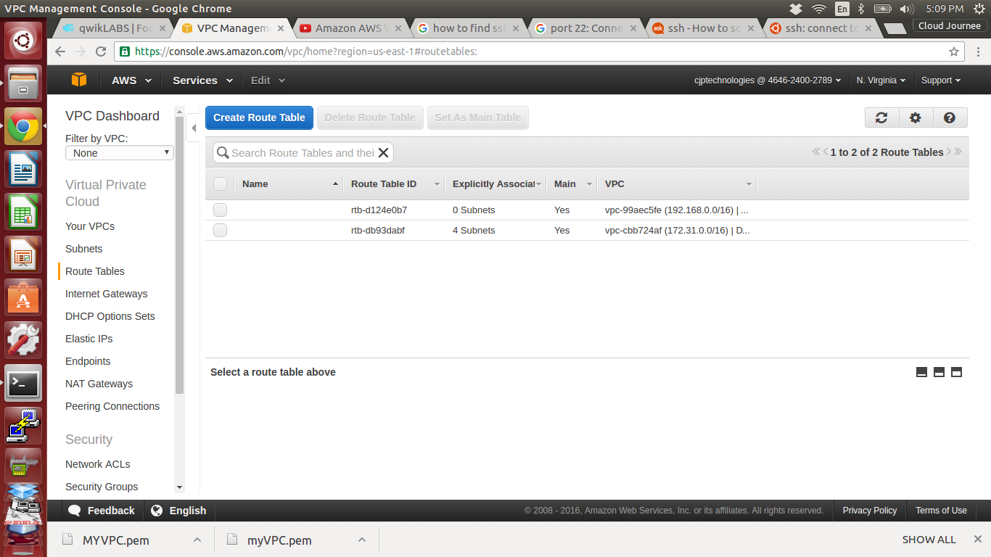

16. Name the Route table as Public_RT and Choose our VPC

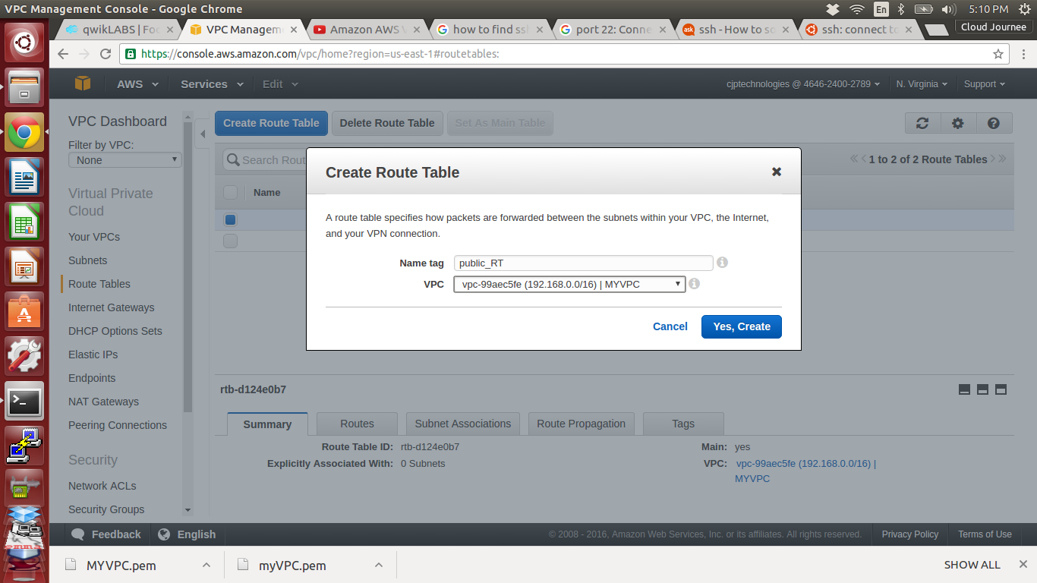



17. Public_RT created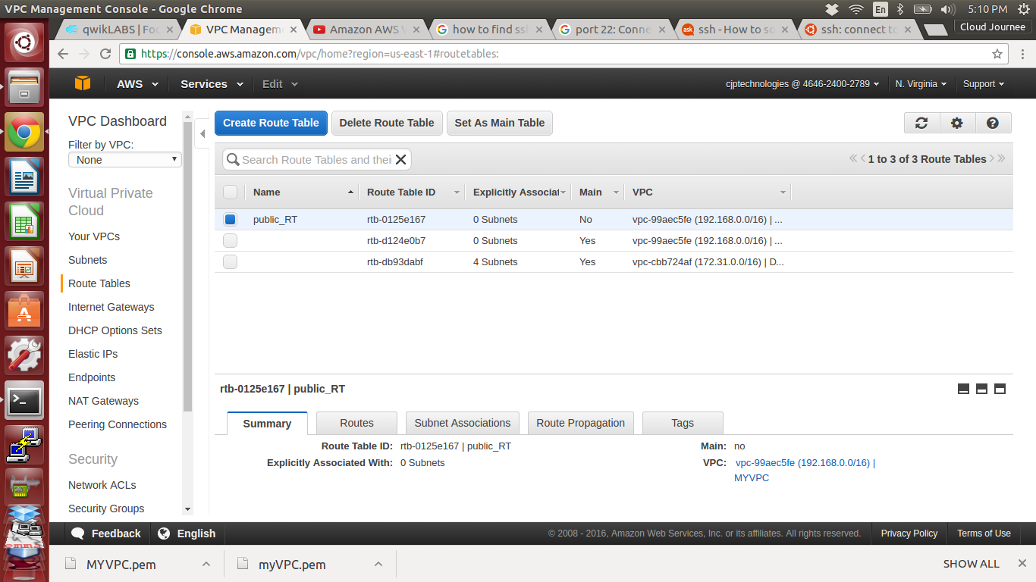



18. Like same way Create Private_RT

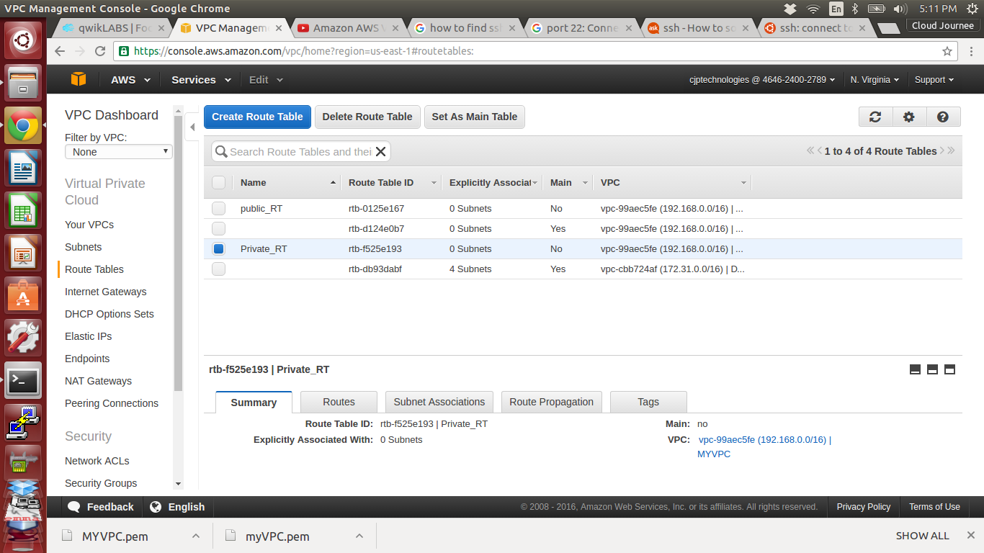

19. Right click on Public_RT and click set as main table

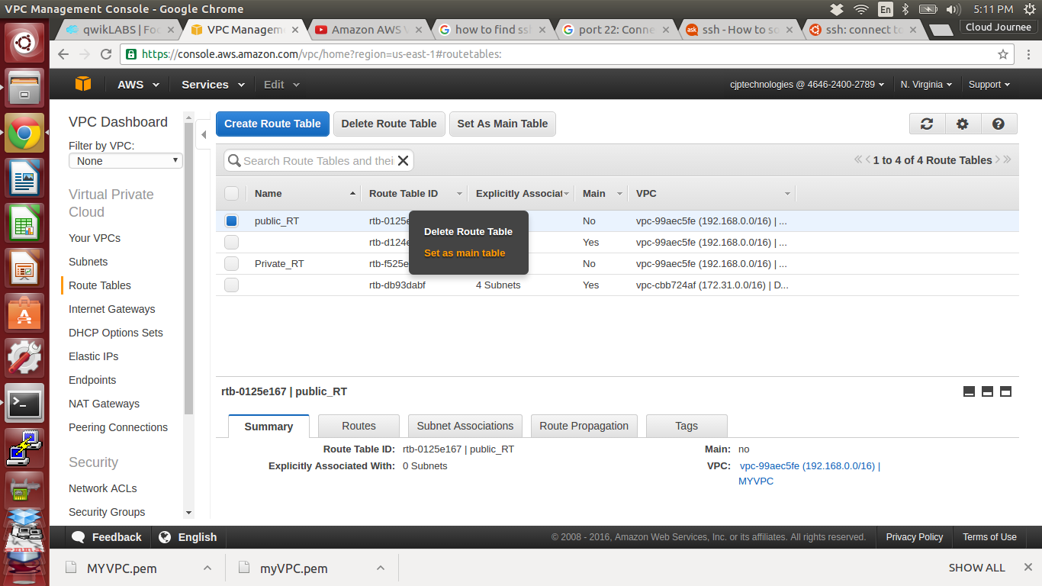

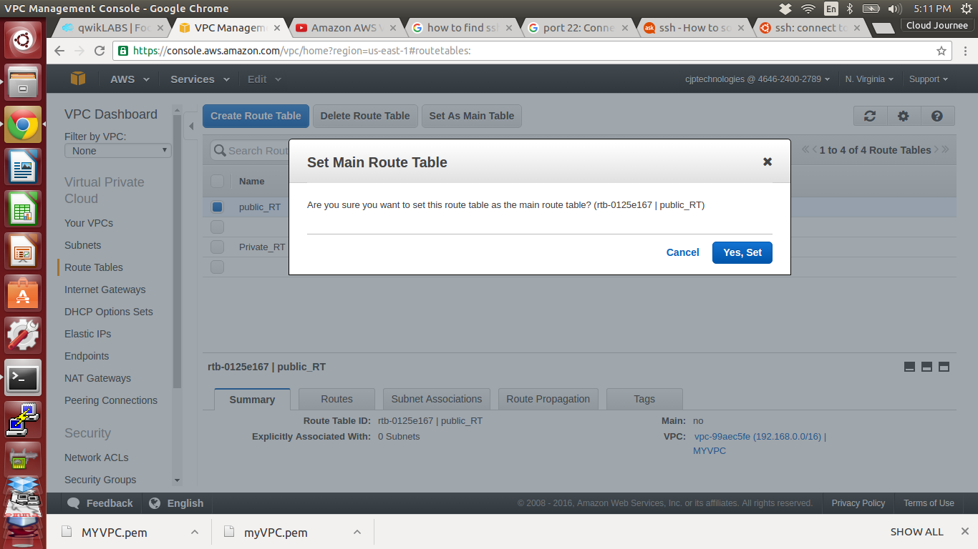

20. Go to *Internet Gateways* under VPC on left tab, and click Create Internet Gateways

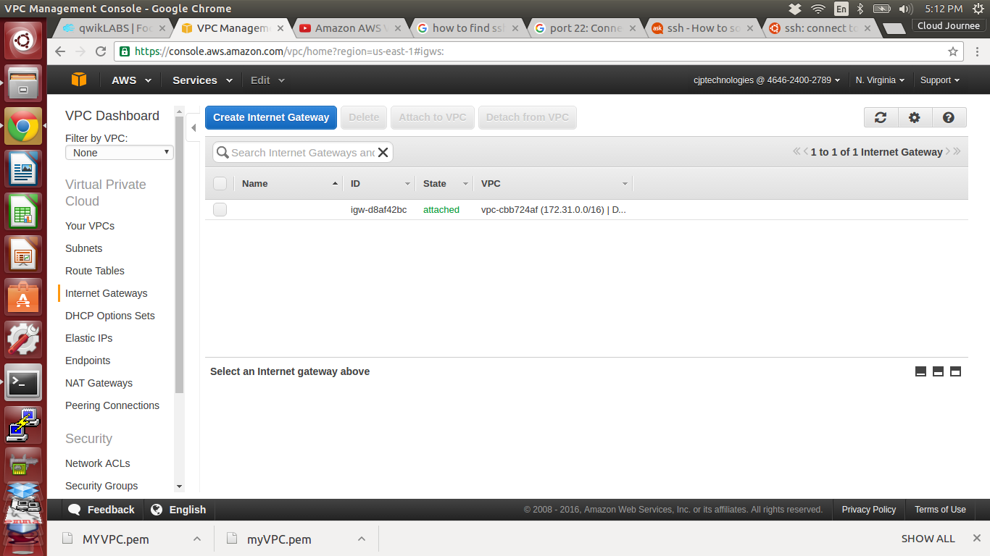

21. Create a new Internet Gateway as MYIGW

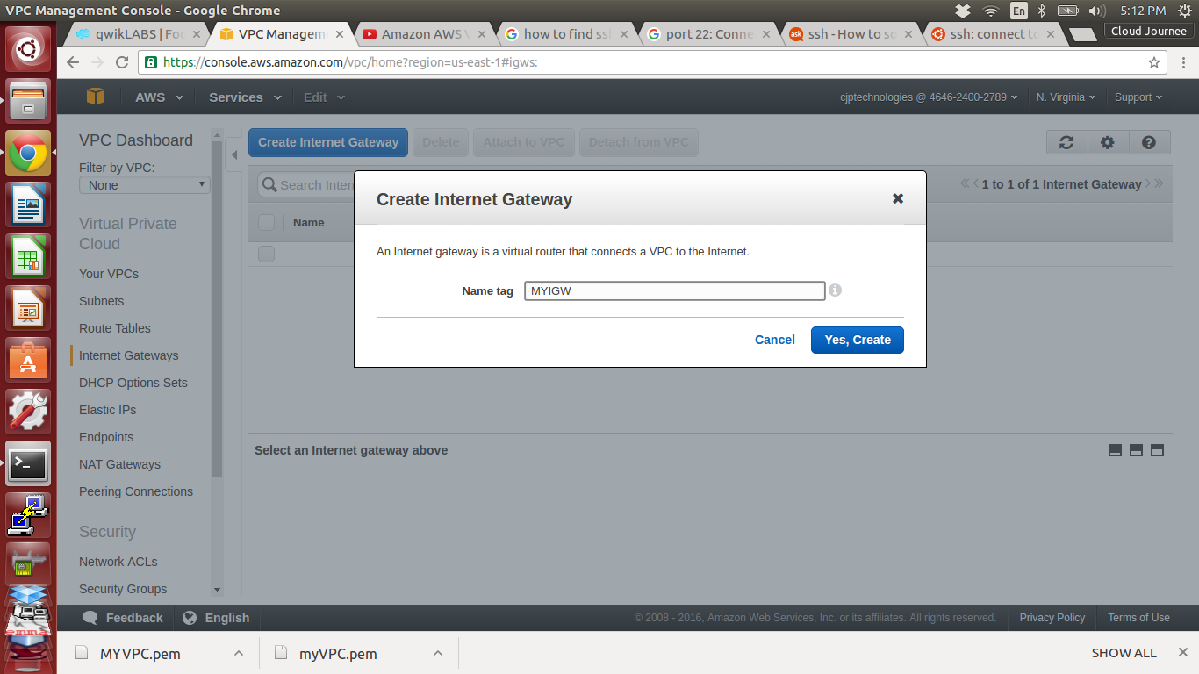

22. MYIGW is created

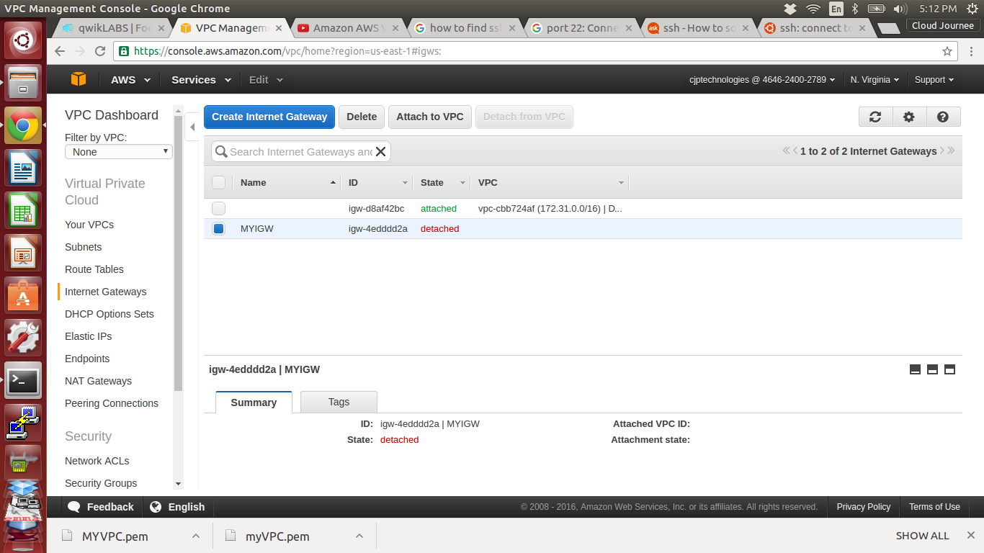

23. Attach the MYIGW to our MYVPC

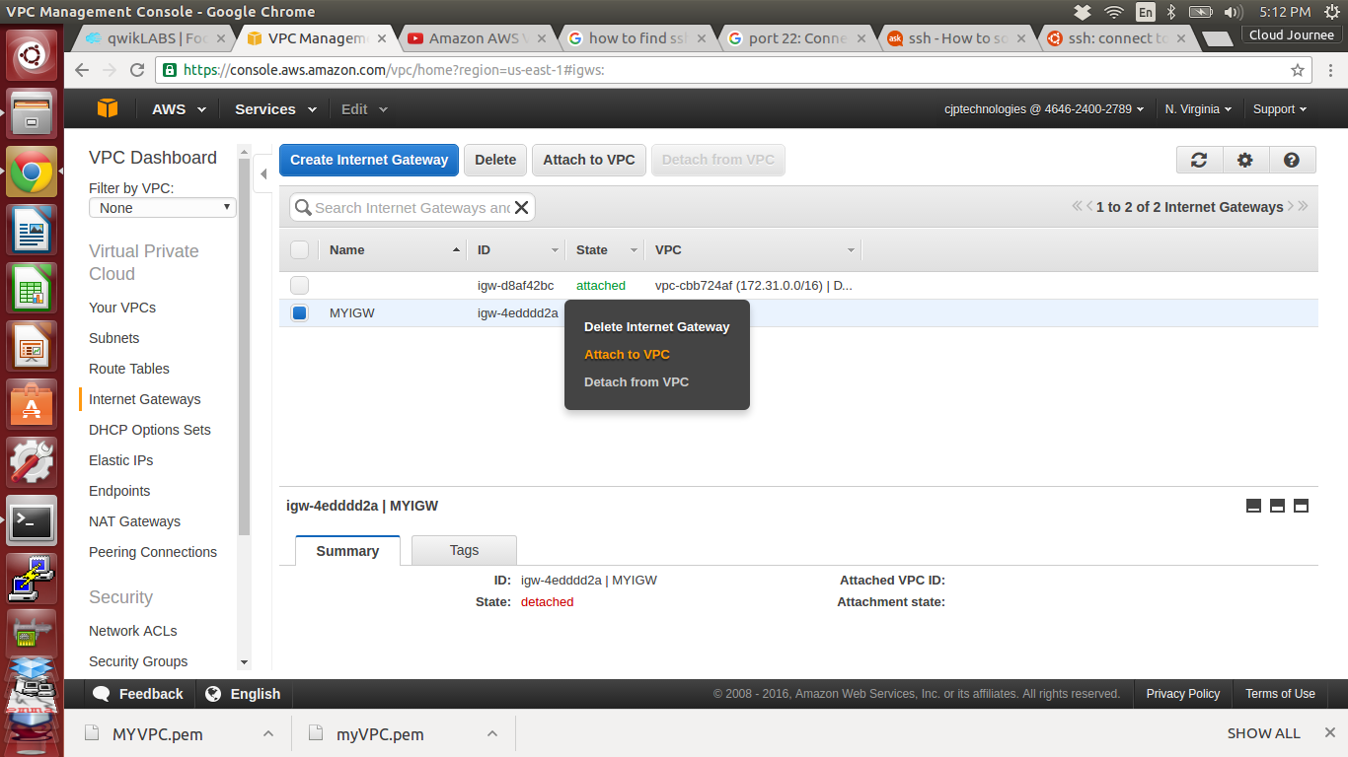

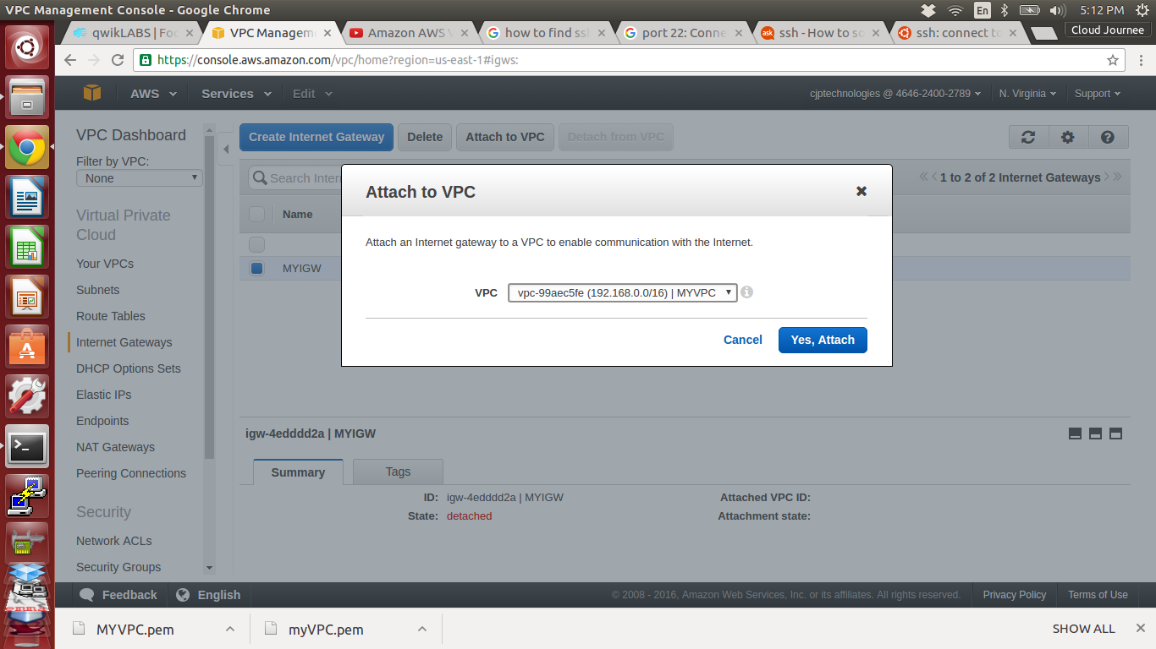

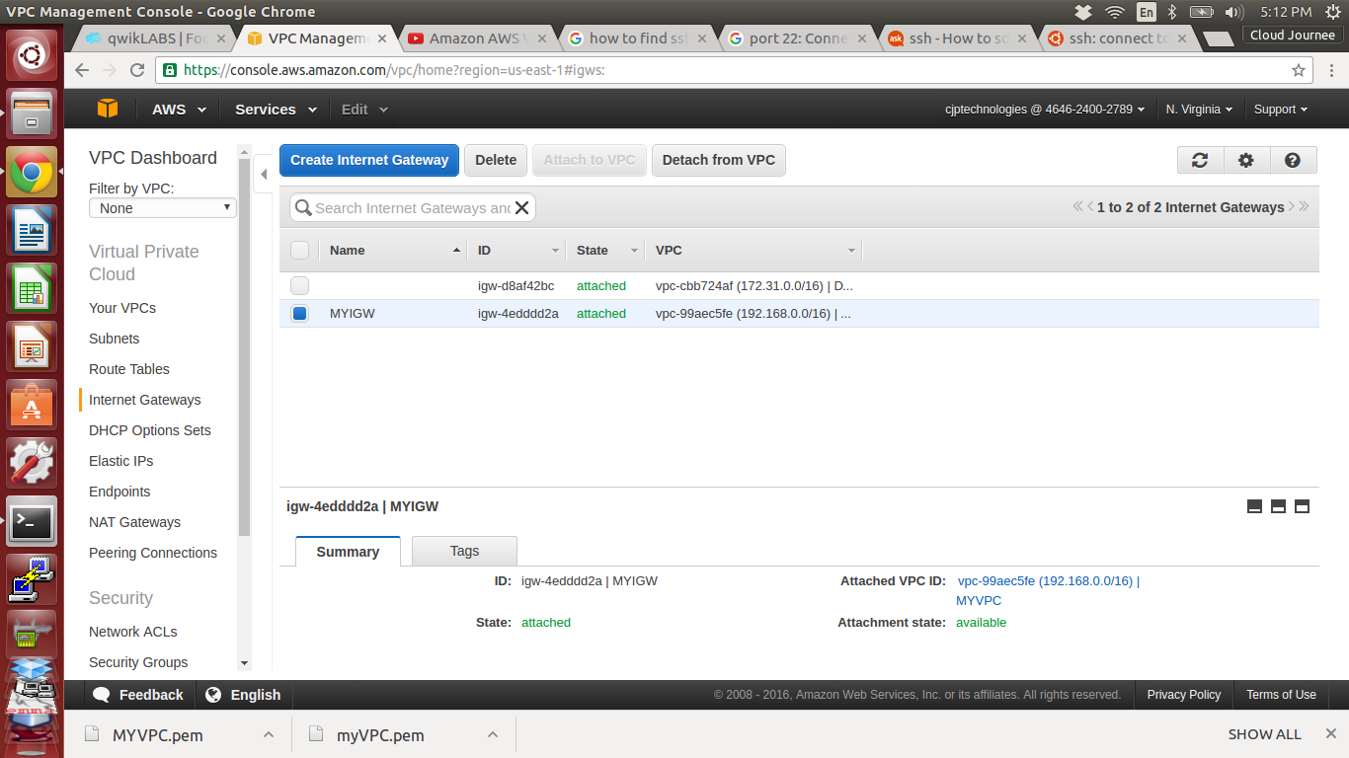

24. Go to our Public_RT select Routes

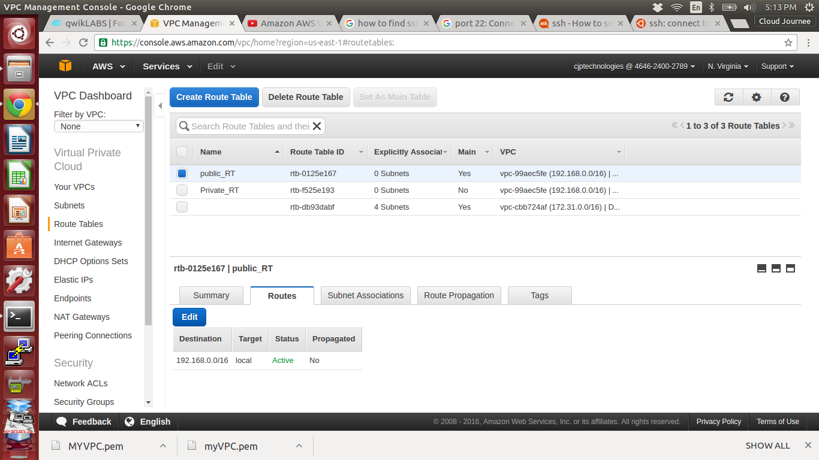

25. Edit and Click Add another route

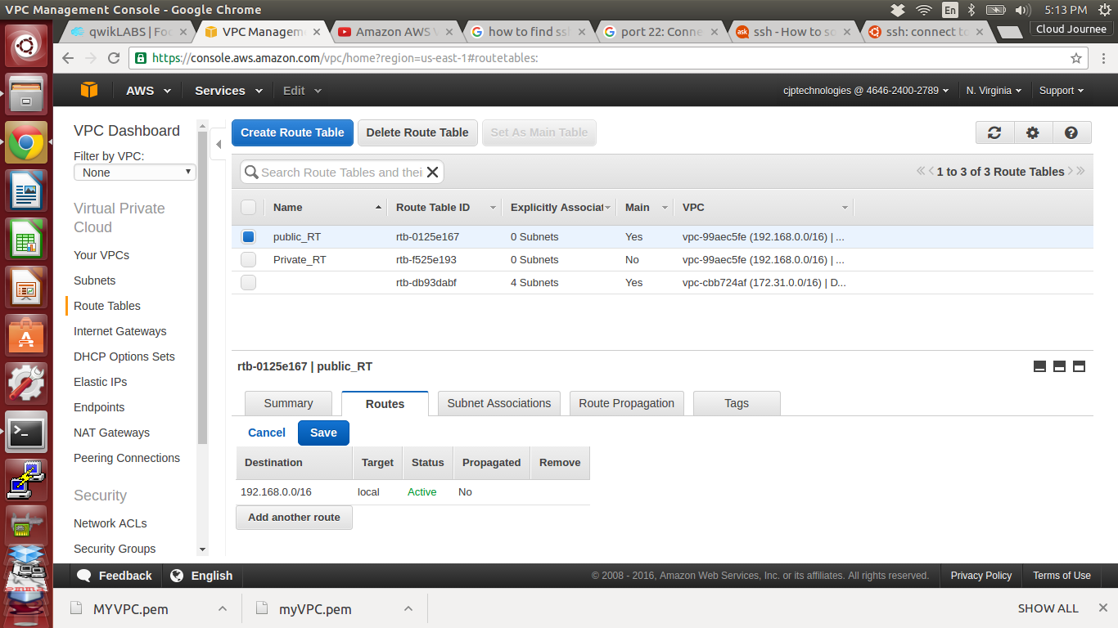

26. Add another route destination

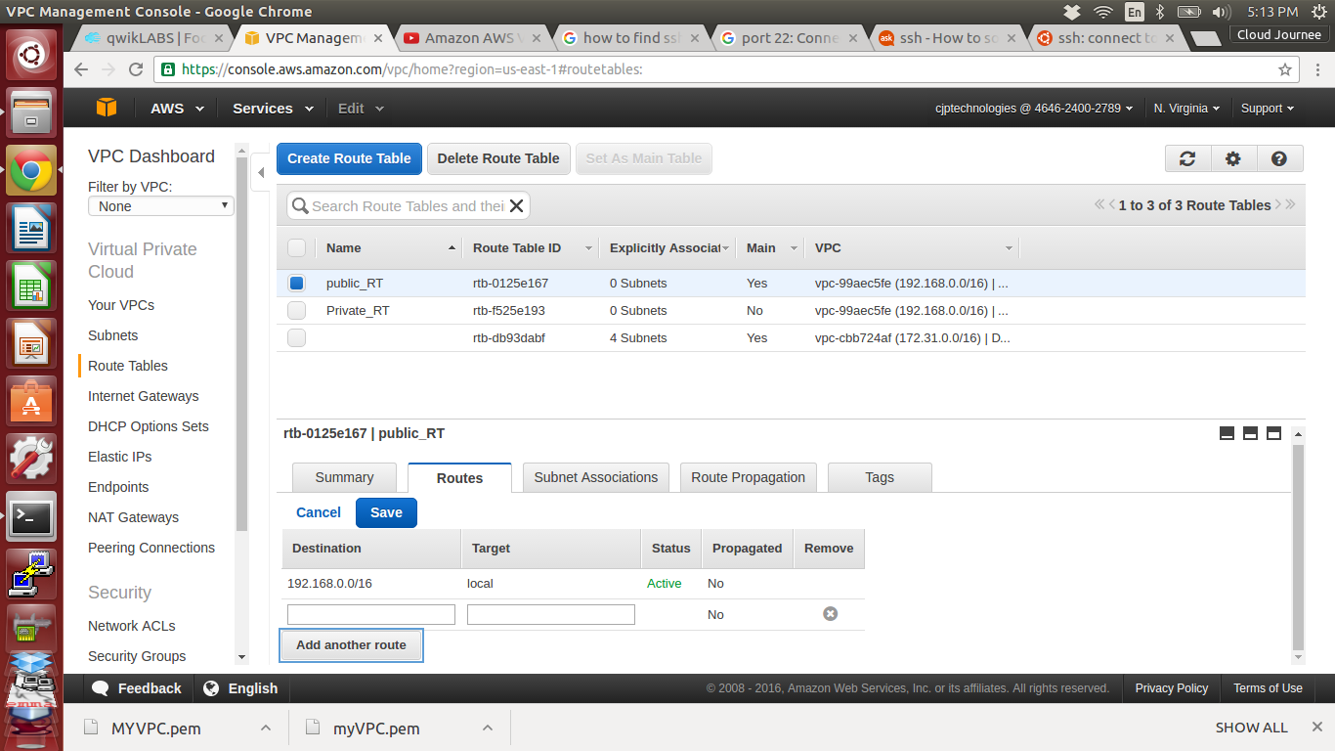

27. give destination as 0.0.0.0/0 and target as our Internet gateway MYIGW and save

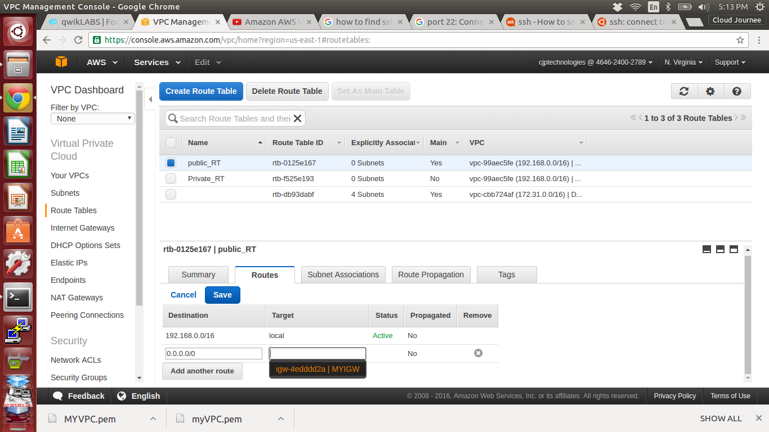

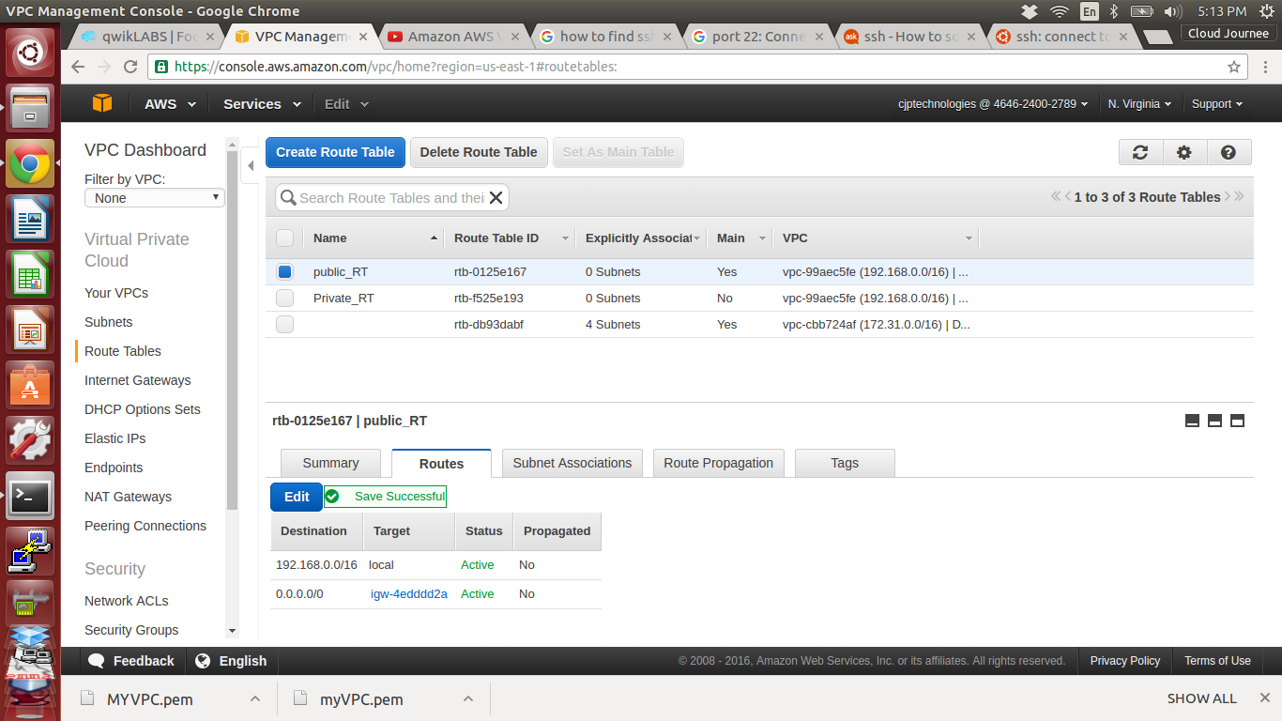

28. Select Subnet Associations Click Edit

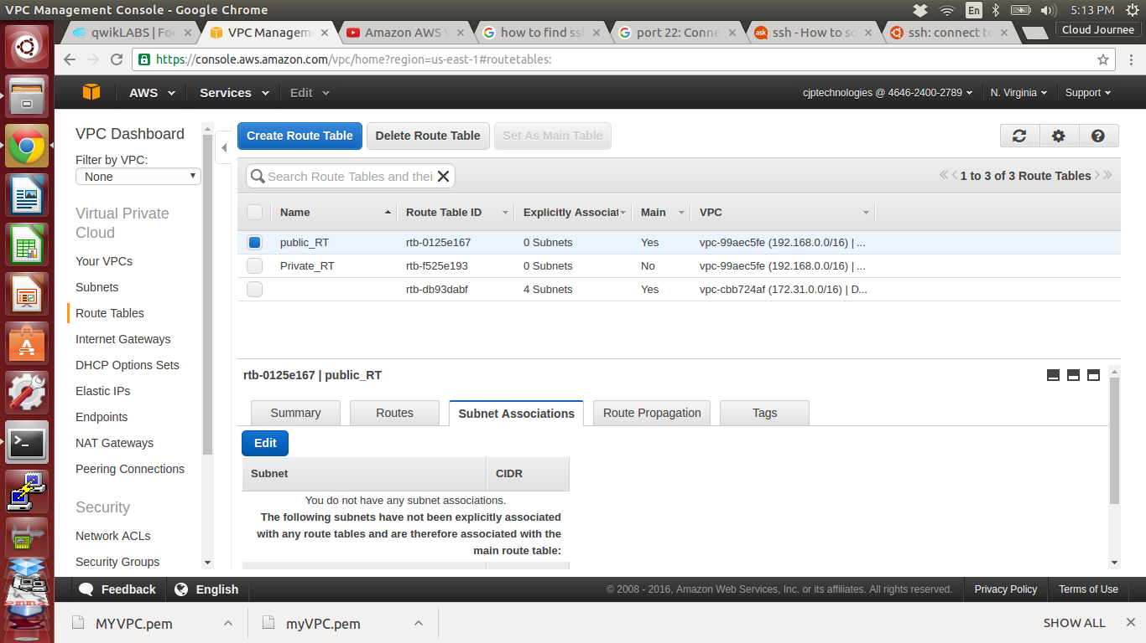

29. Select Public_sub and save

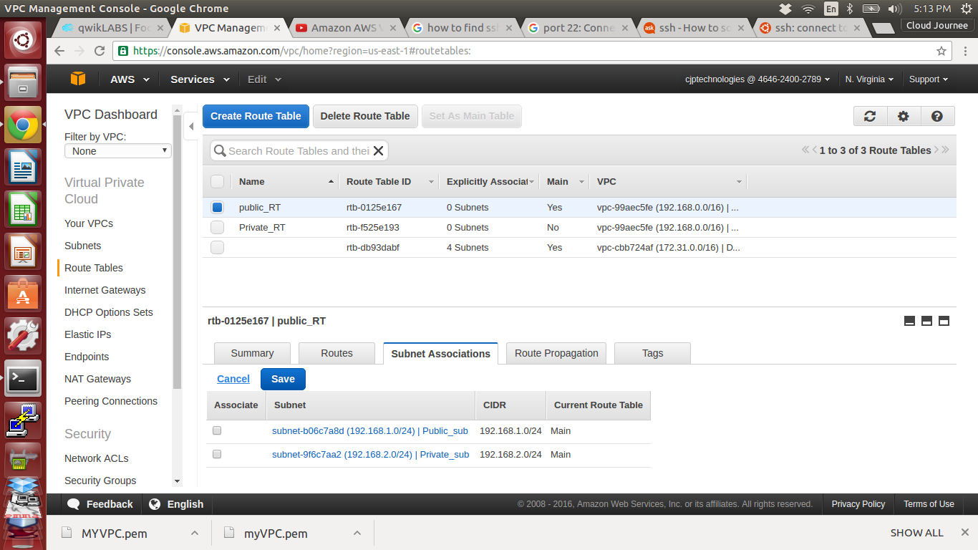

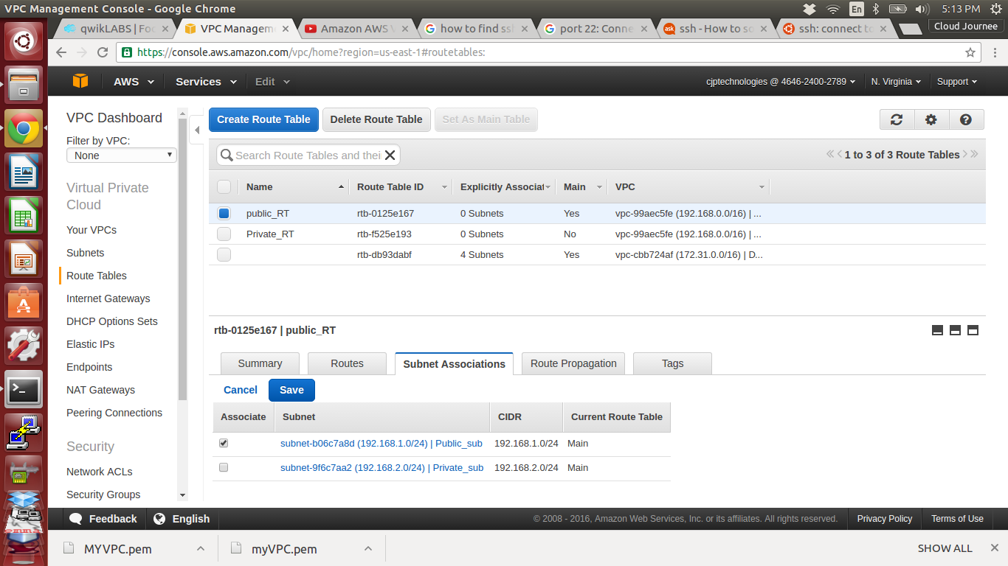

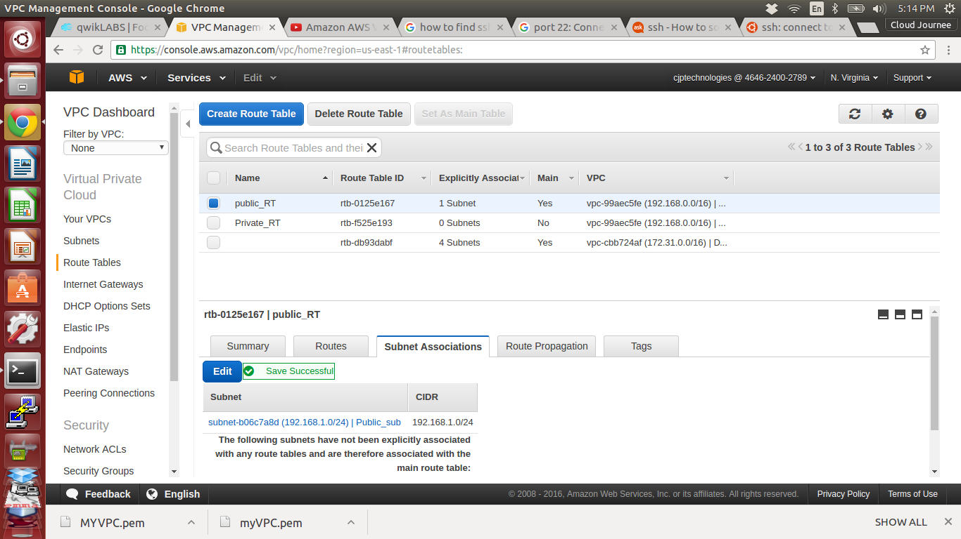

30. Do same thing in Private_RT and choose Private_sub in Subnet Associations and save

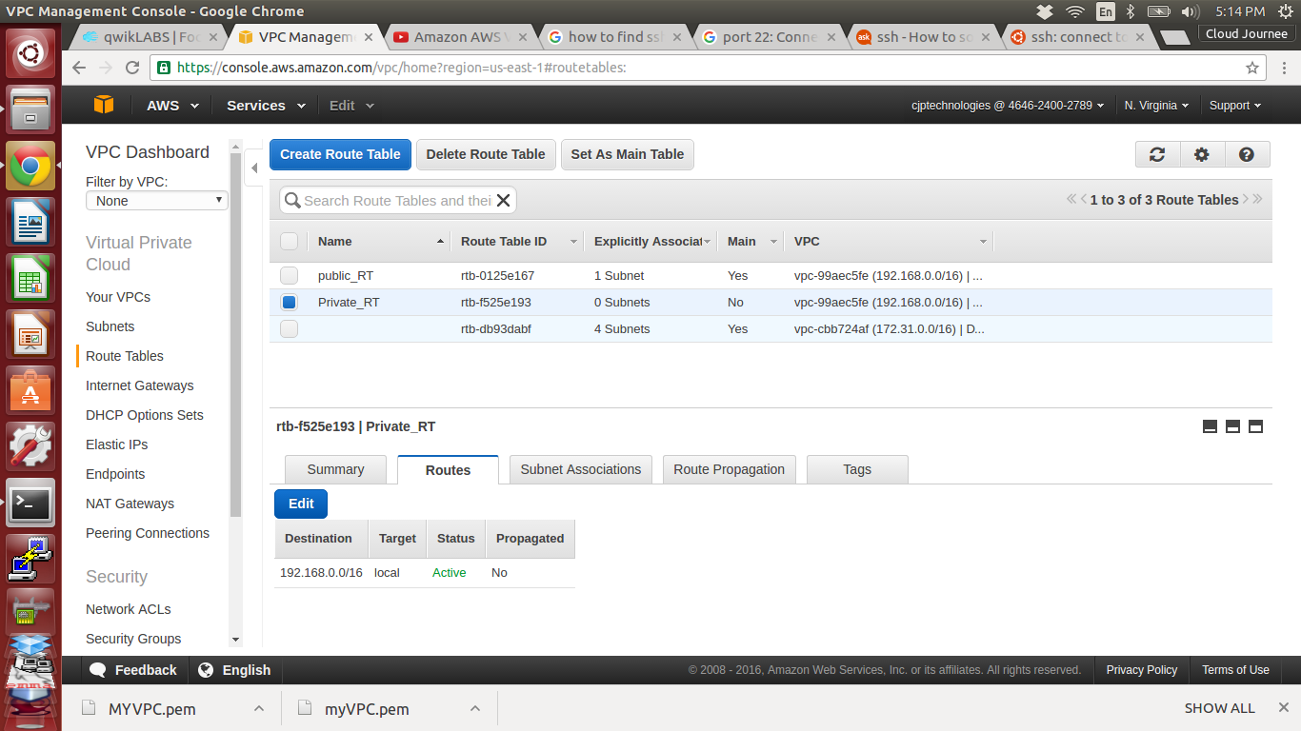

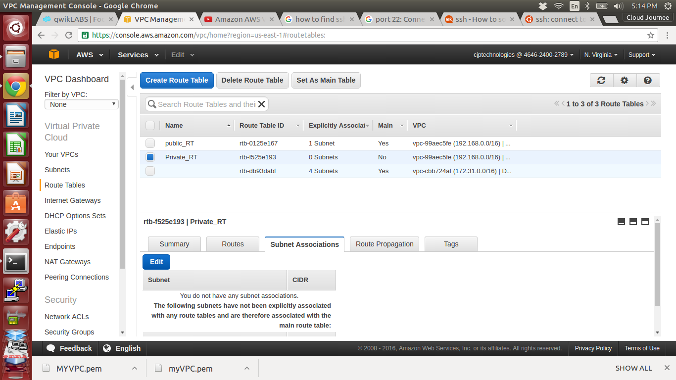

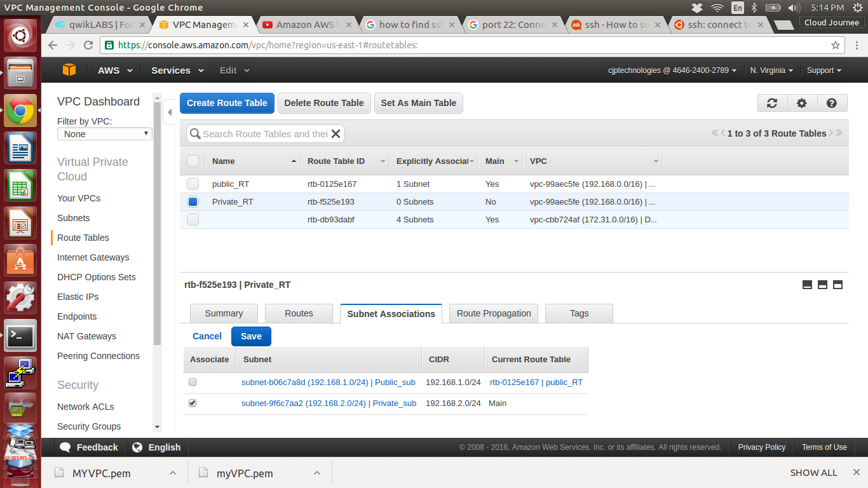

31. Go to *Security Groups* under VPC on left tab, and click Create Security Groups

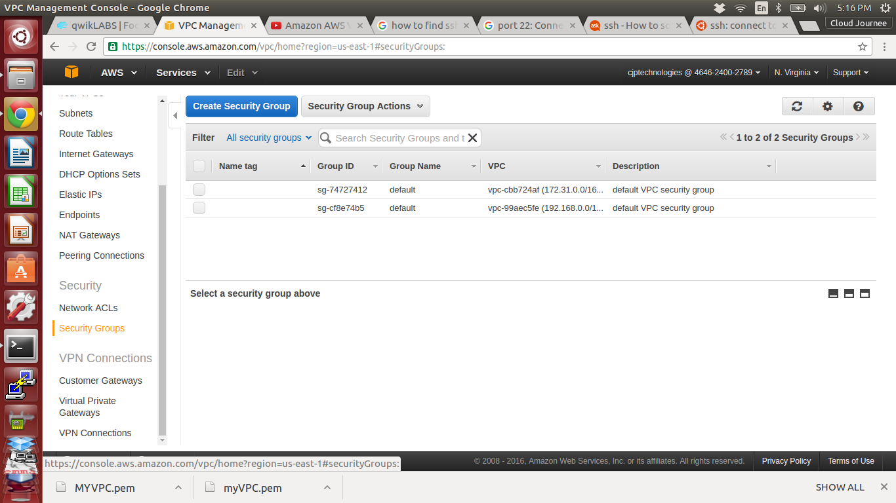

32. Assign name, Group name, Description and Choose our VPC

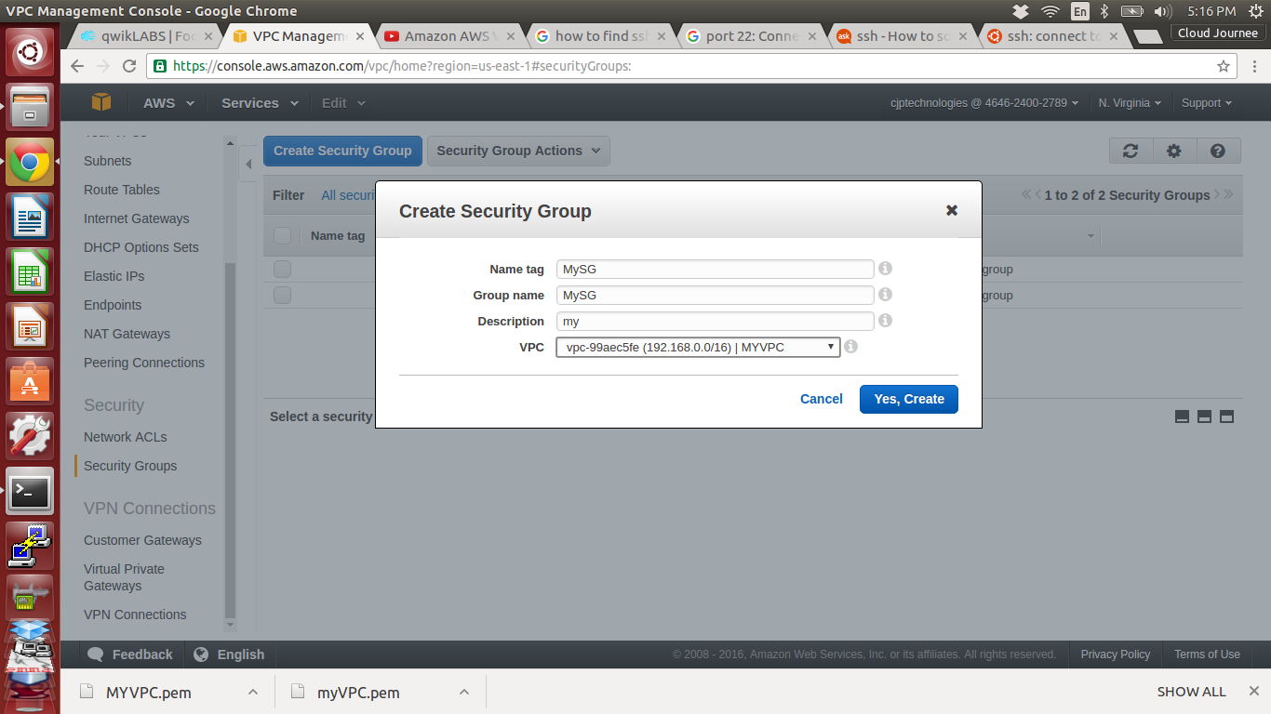

33. MYSG is Created

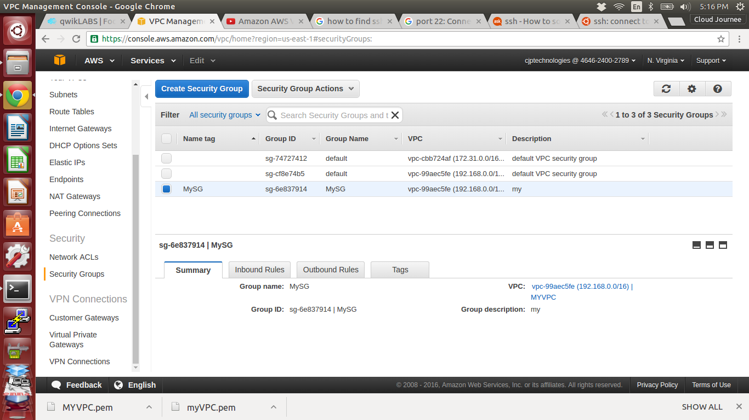

34. Select Inbound Rules and set the rules

SSH,HTTP,HTTPS,ALL ICMP (for telnet ) - source as 0.0.0.0/0 (everyone can access)

save it

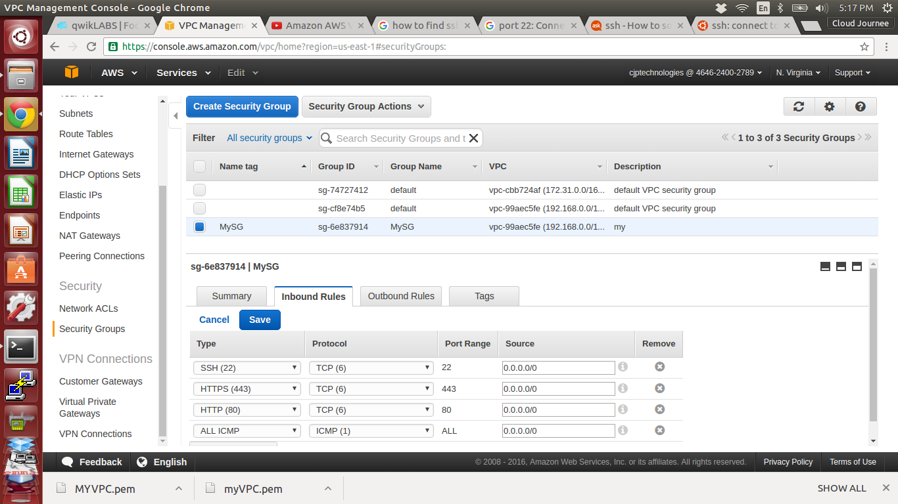

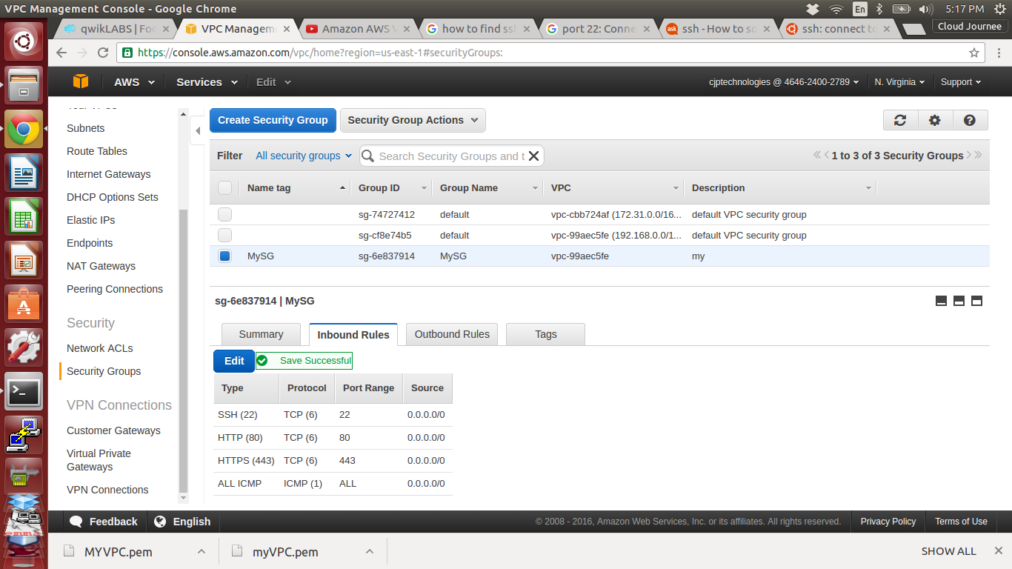

35. Now open Services and choose EC2

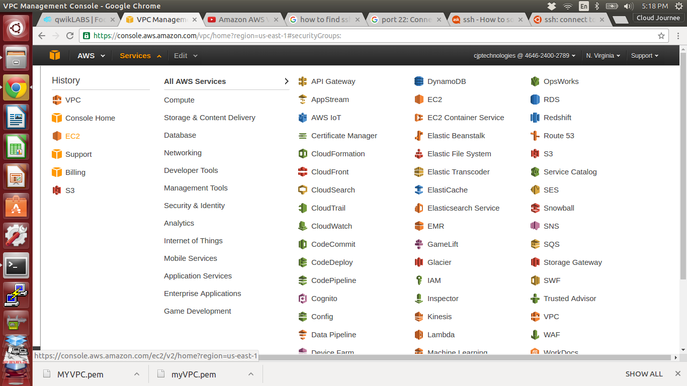

36. Click launch Instance

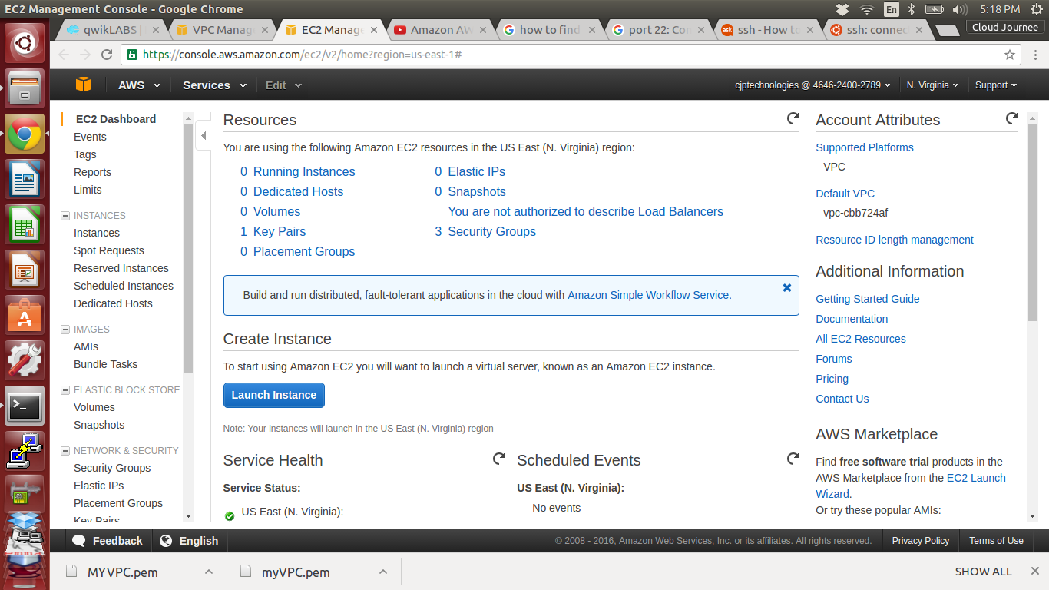

37. Select Amazon Linux for AMI

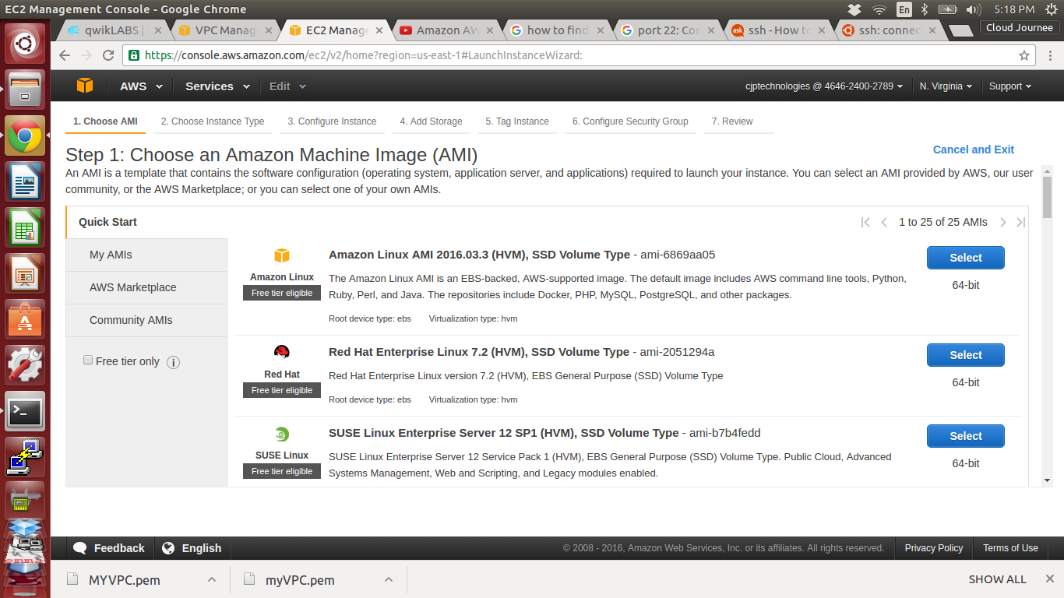

38. Choose instance type as t2.micro and click Next:Configure instance Details

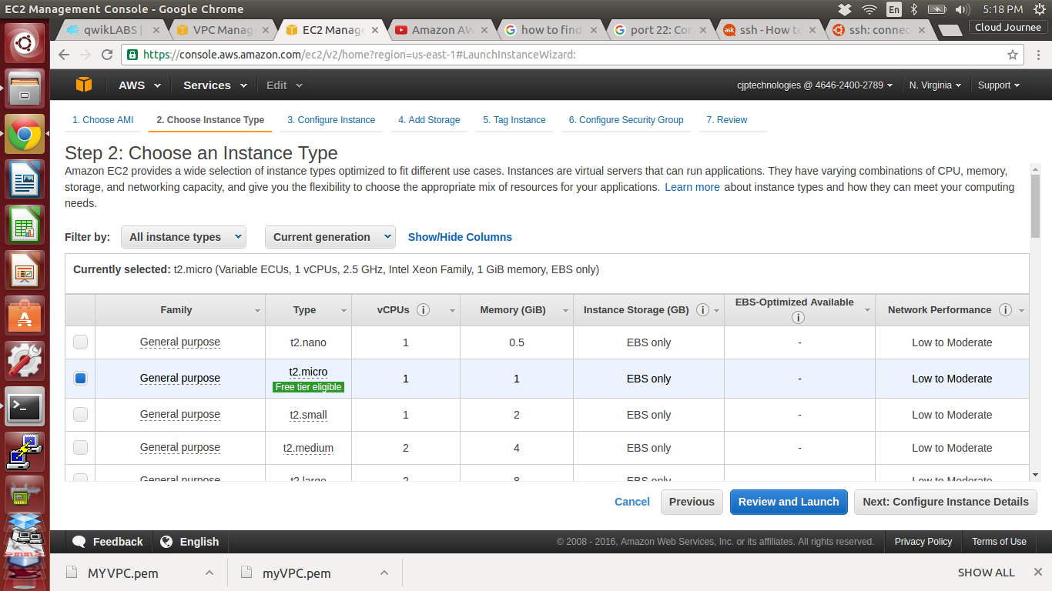

39. Select our MYVPC in Network tab

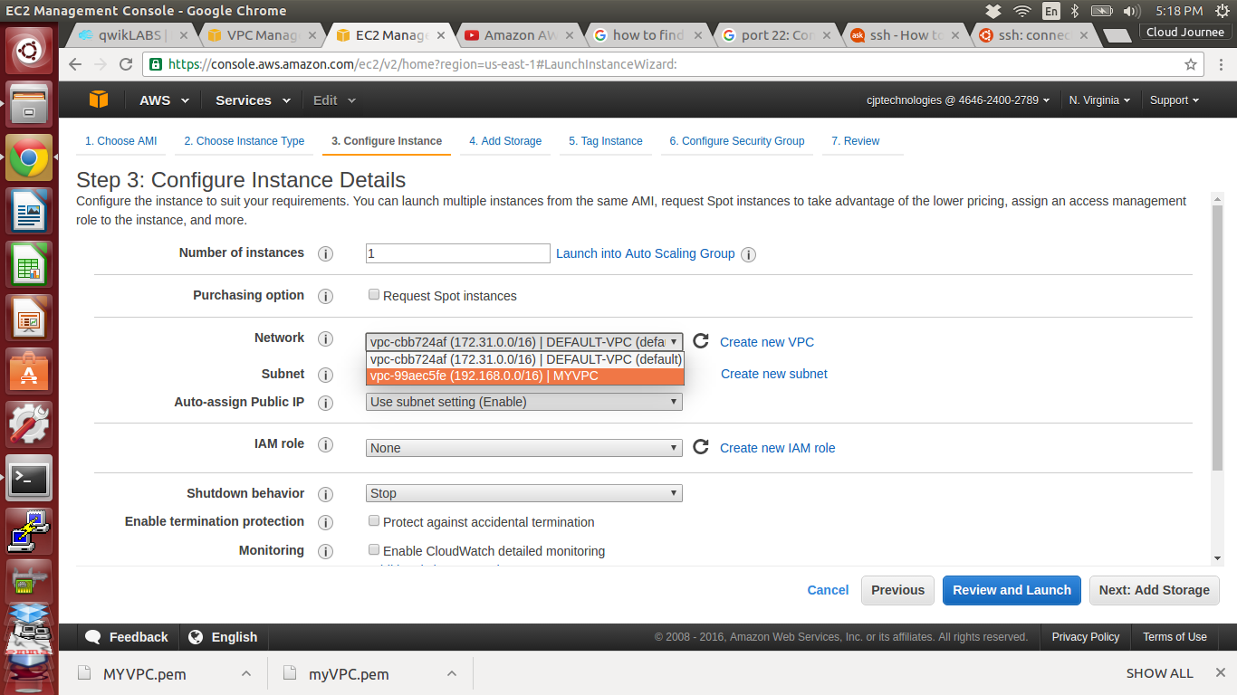

40. Select Public_sub in Subnet tab

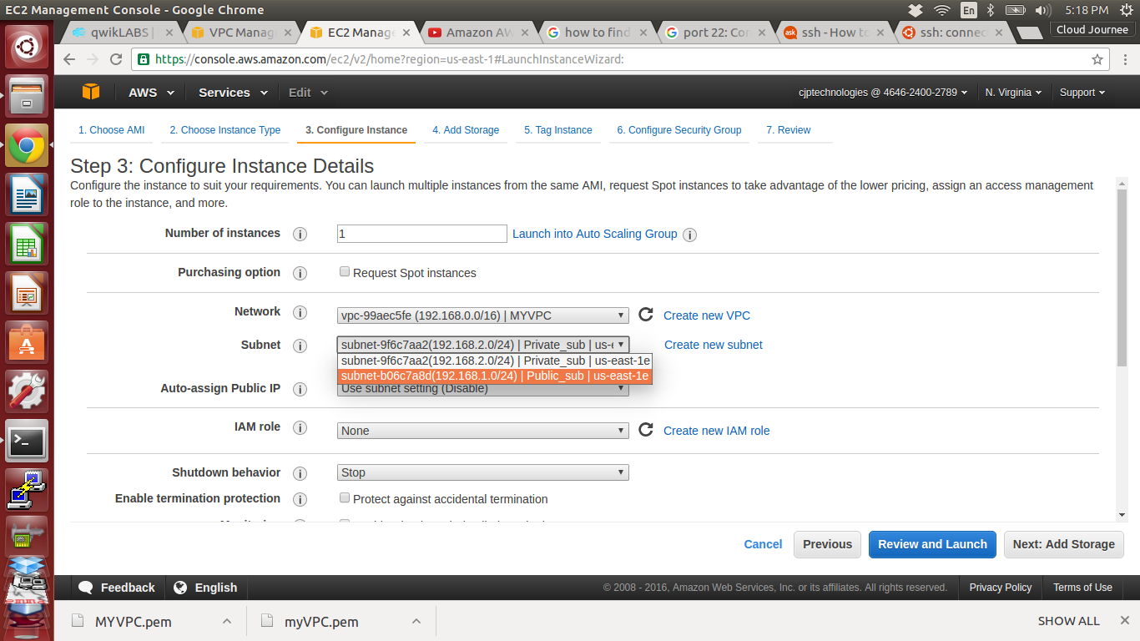

41. Enable Auto-assign Public IP ( only for Public instance )

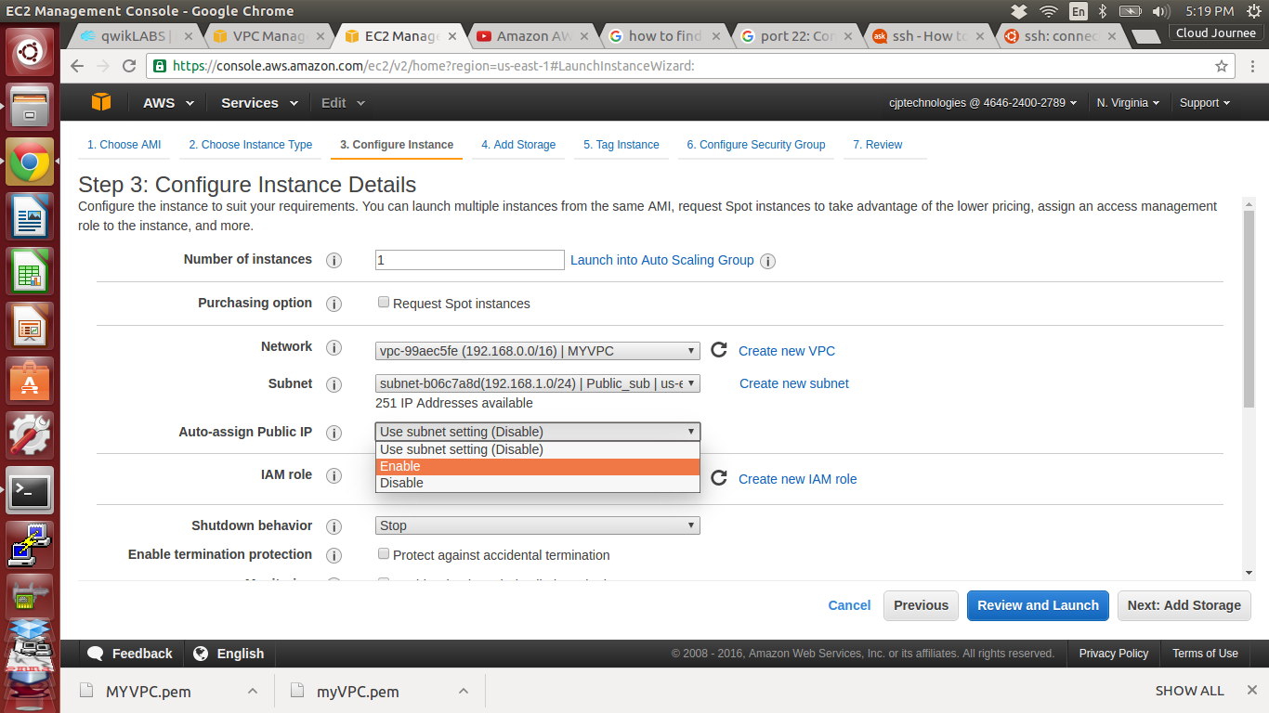

42. Click Next:Add Storage

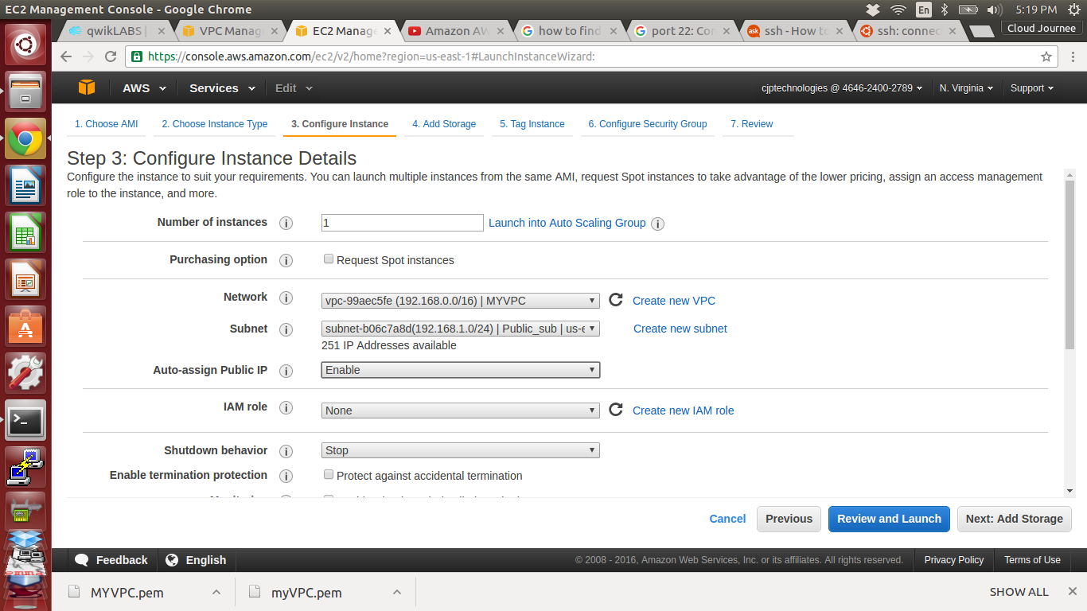

43. Click Next:Tag instance

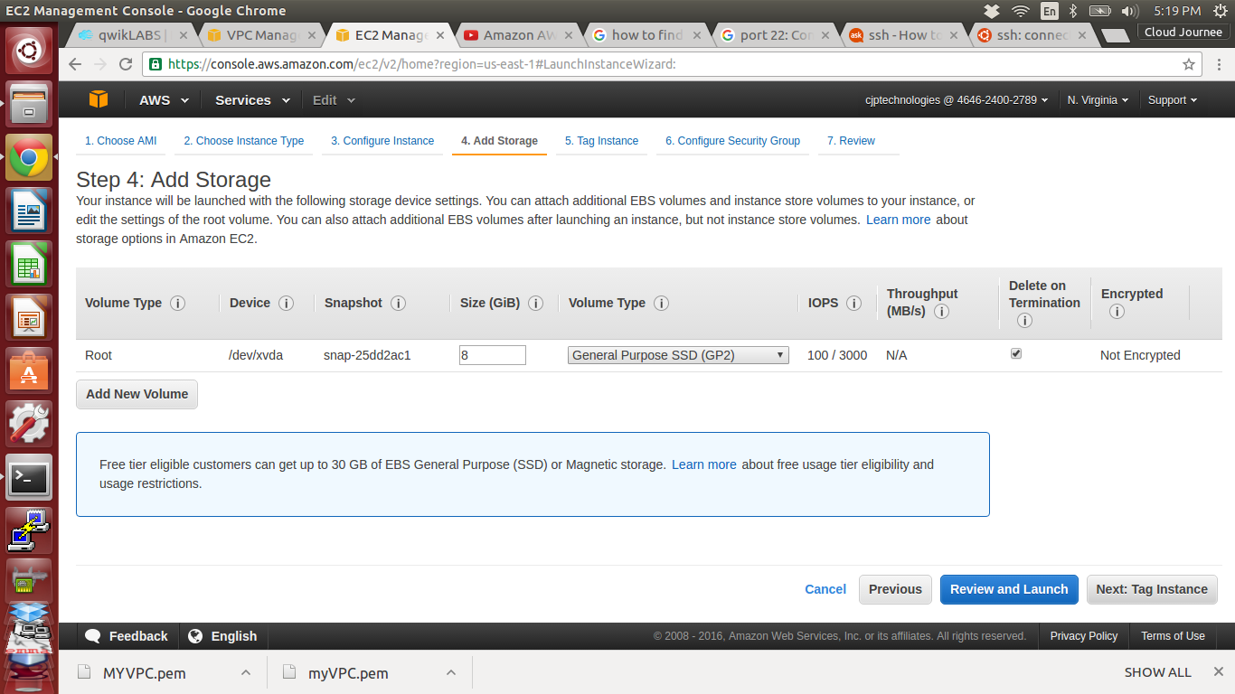

44. Assign Value as PUBLIC ( public instance ) and Click Next:Configure Security Group

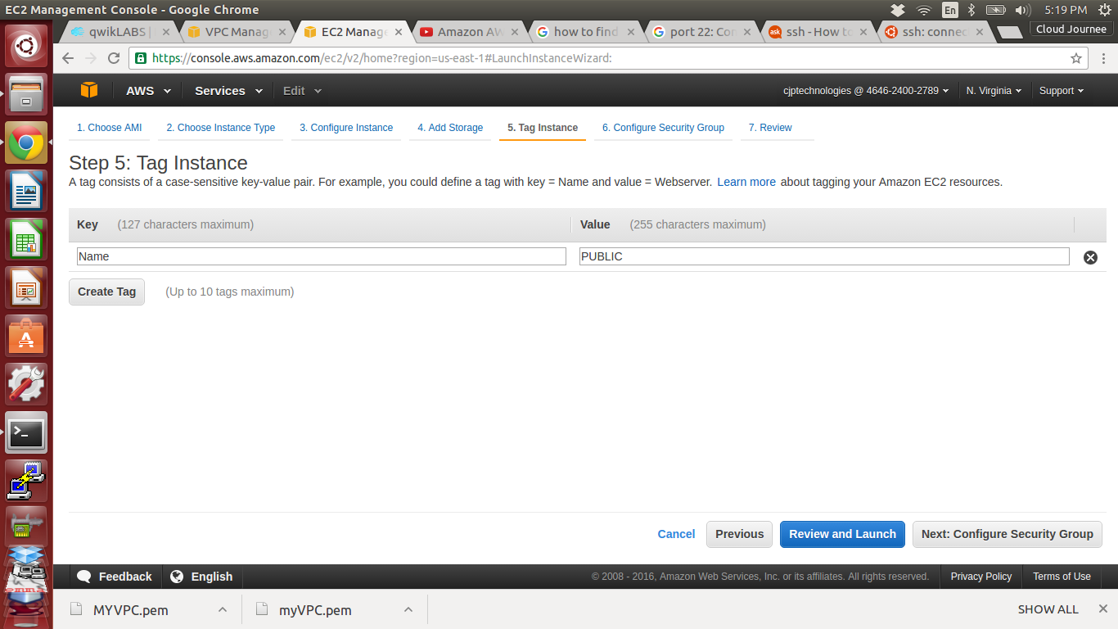

45. Set the security SSH,HTTP,HTTPS and ALL ICMP and make source Anywhere 0.0.0.0/0

Click Review and Launch

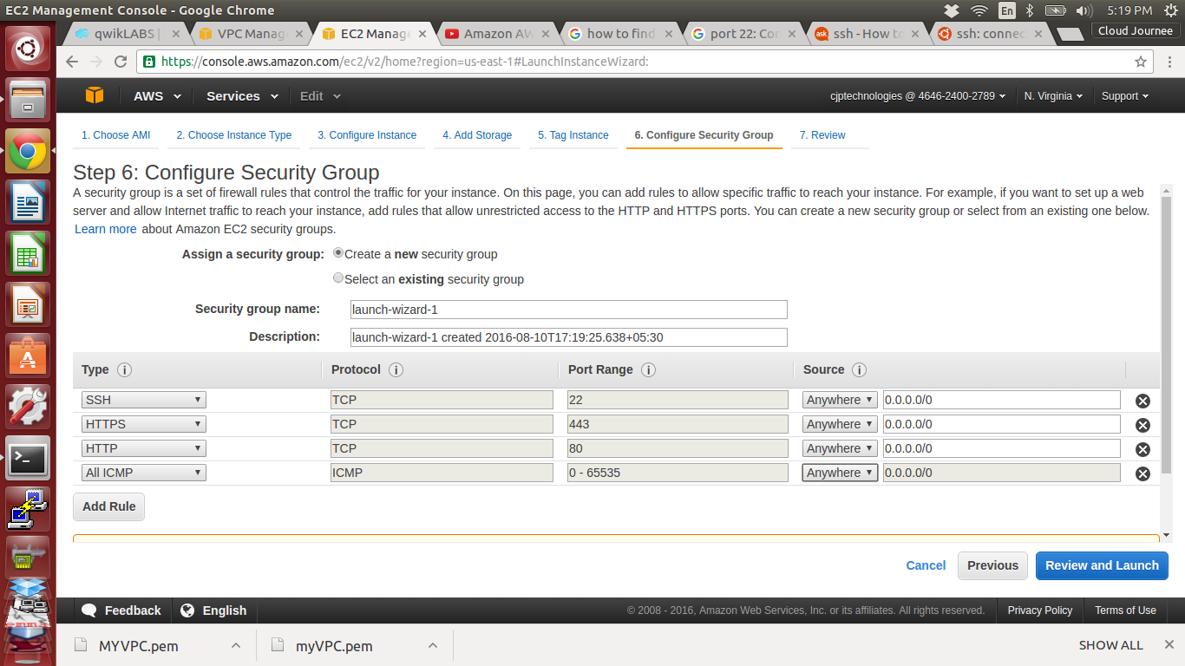

46. Check the instance once for confirmation and Launch

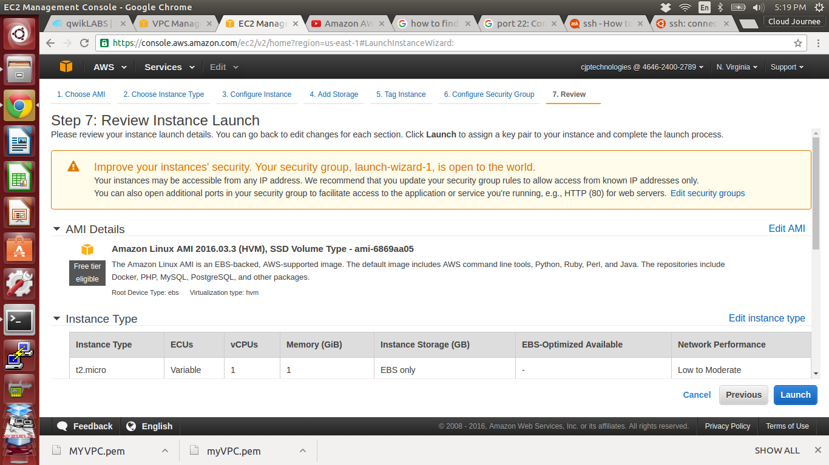

47. Create a new key pair and Download it then Click Launch instance

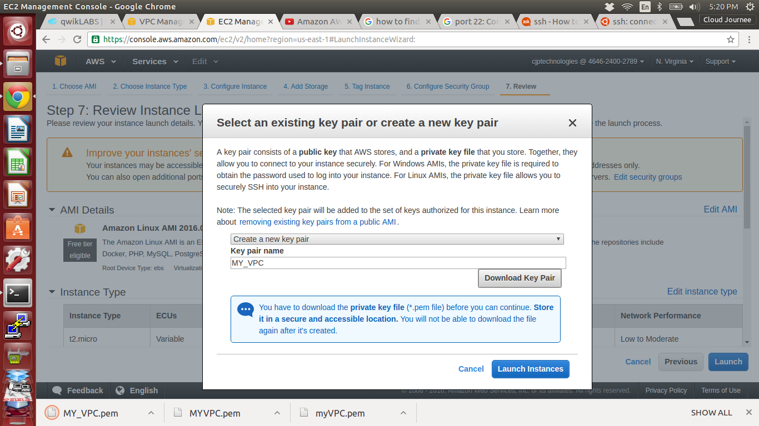

48. PUBLIC instance created

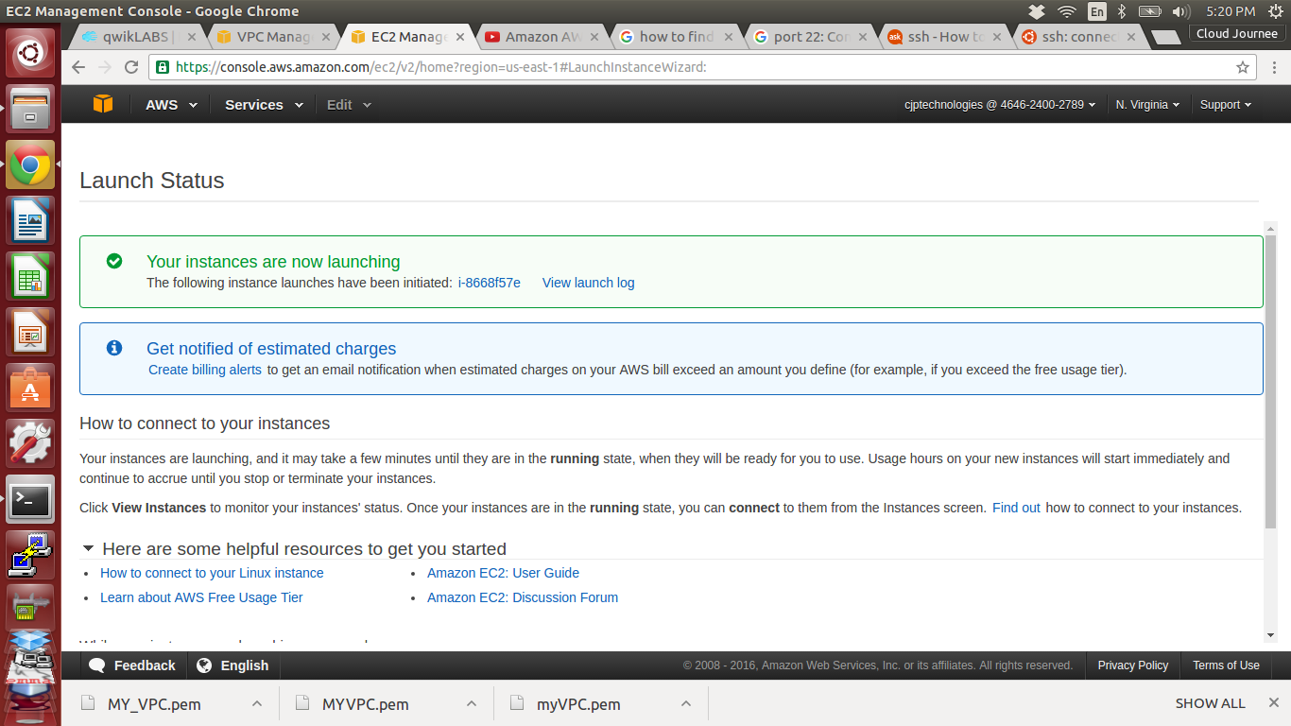

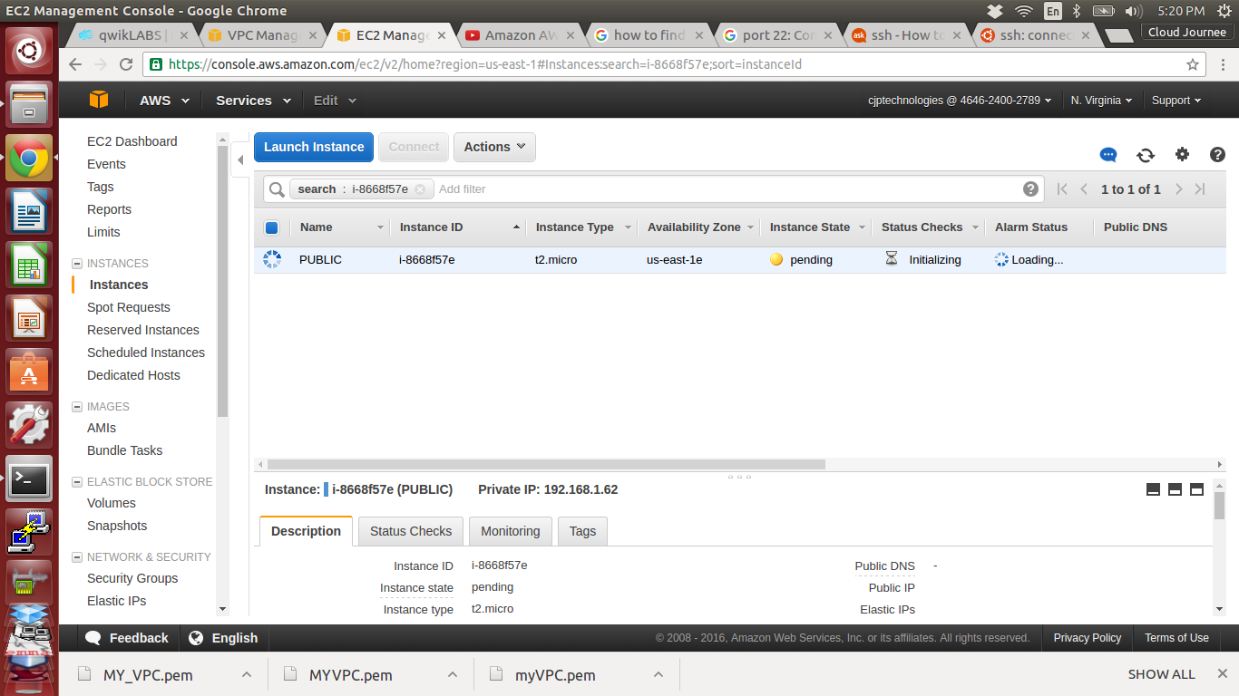

49. Create a new instance and named as PRIVATE

In Configure instance

* Select our MYVPC in Network
* Select Private_sub in Subnet

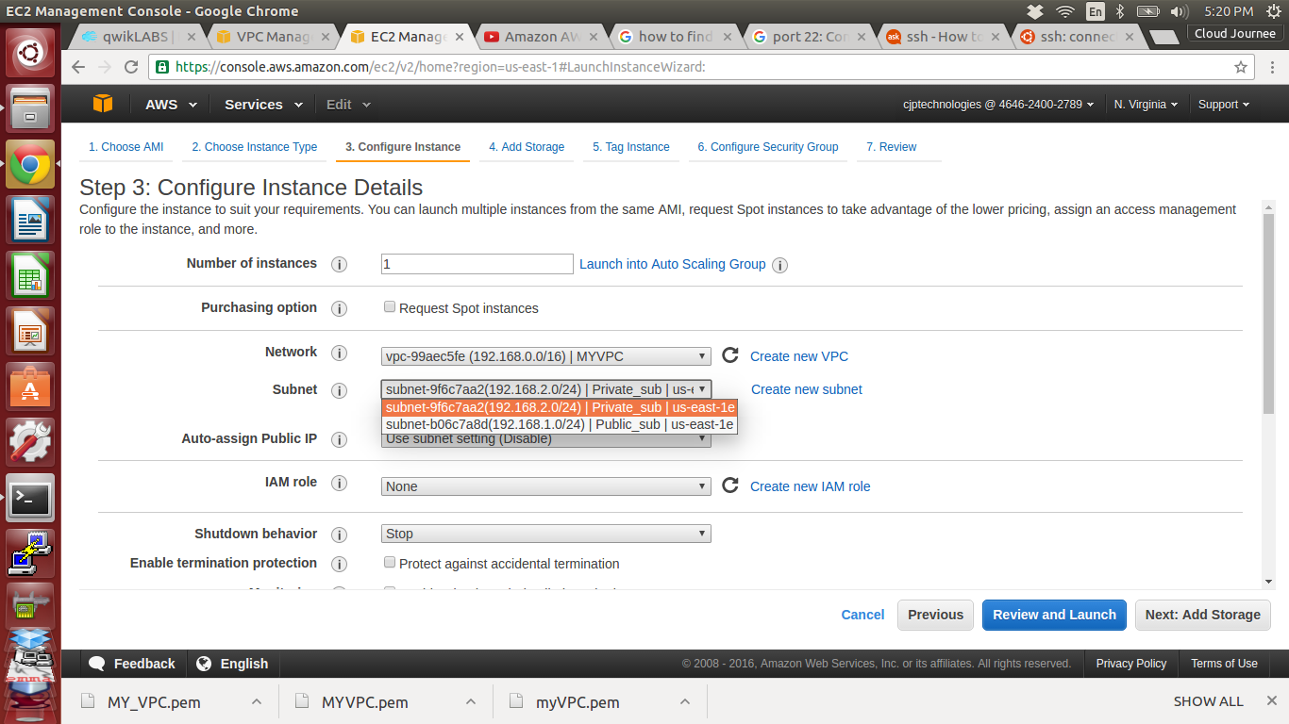

50. Click Next:Add Storage

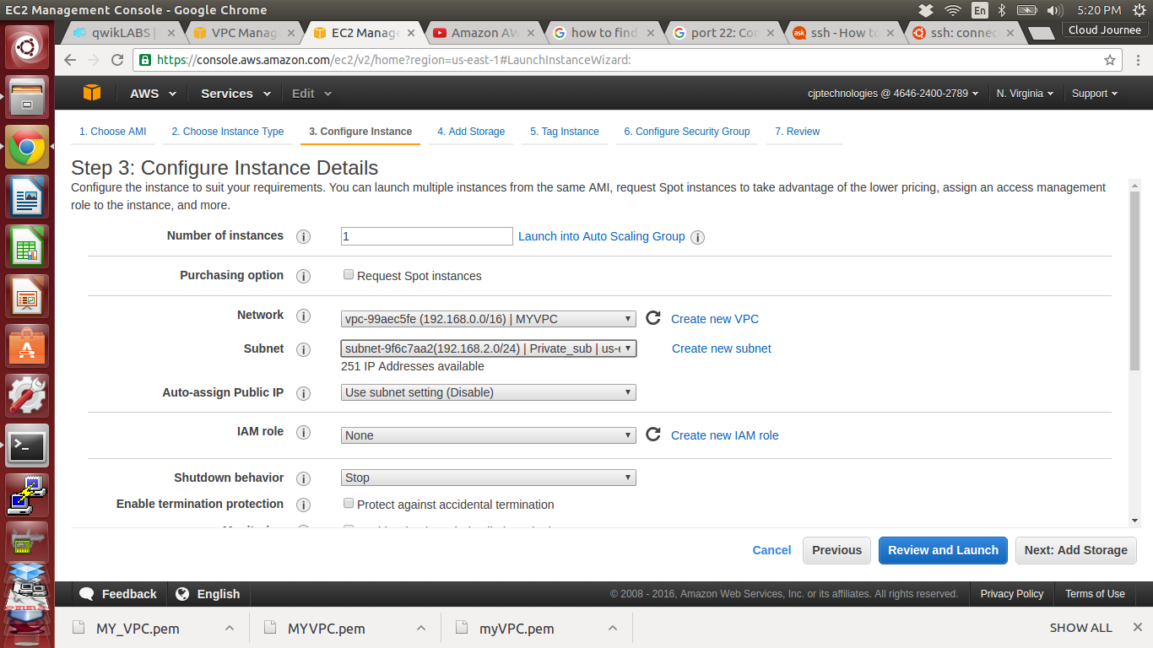

51. Click Next:Tag Instance

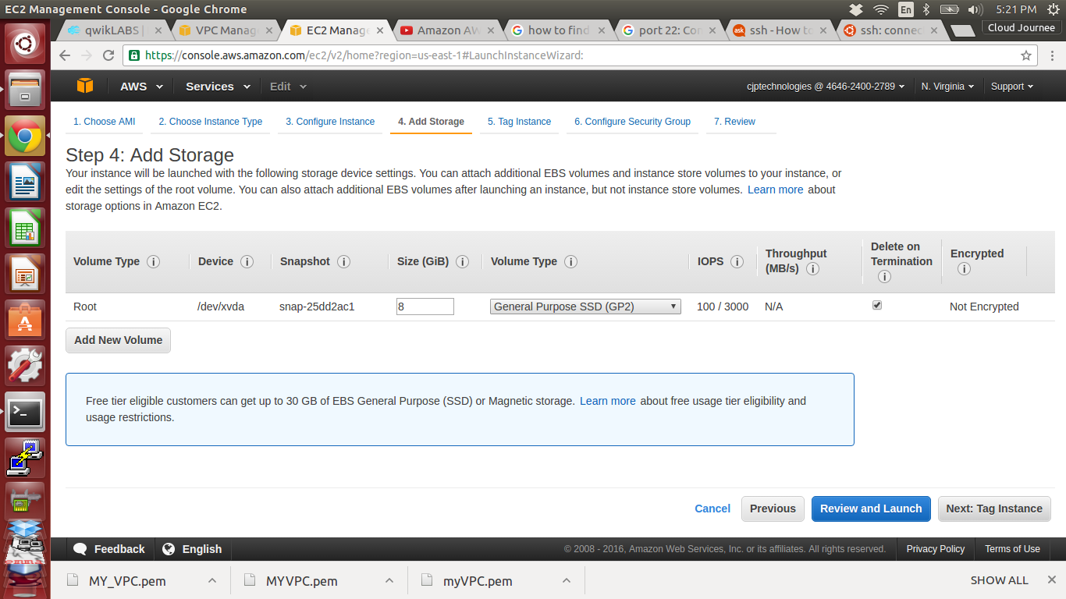

52. Assign Value as PRIVATE and Click Next:Configure Security Group

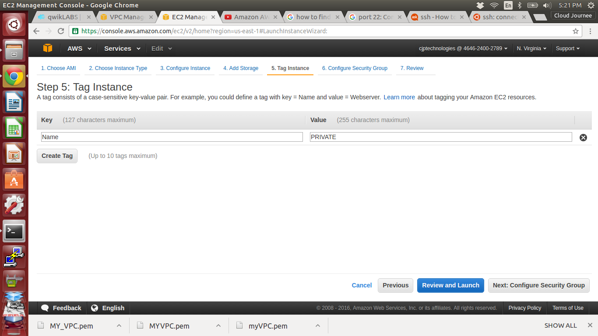

53. Set SSH and ALL ICMP and source as Custom 192.168.0.0/16 (MYVPC ip address)

Click Review and Launch

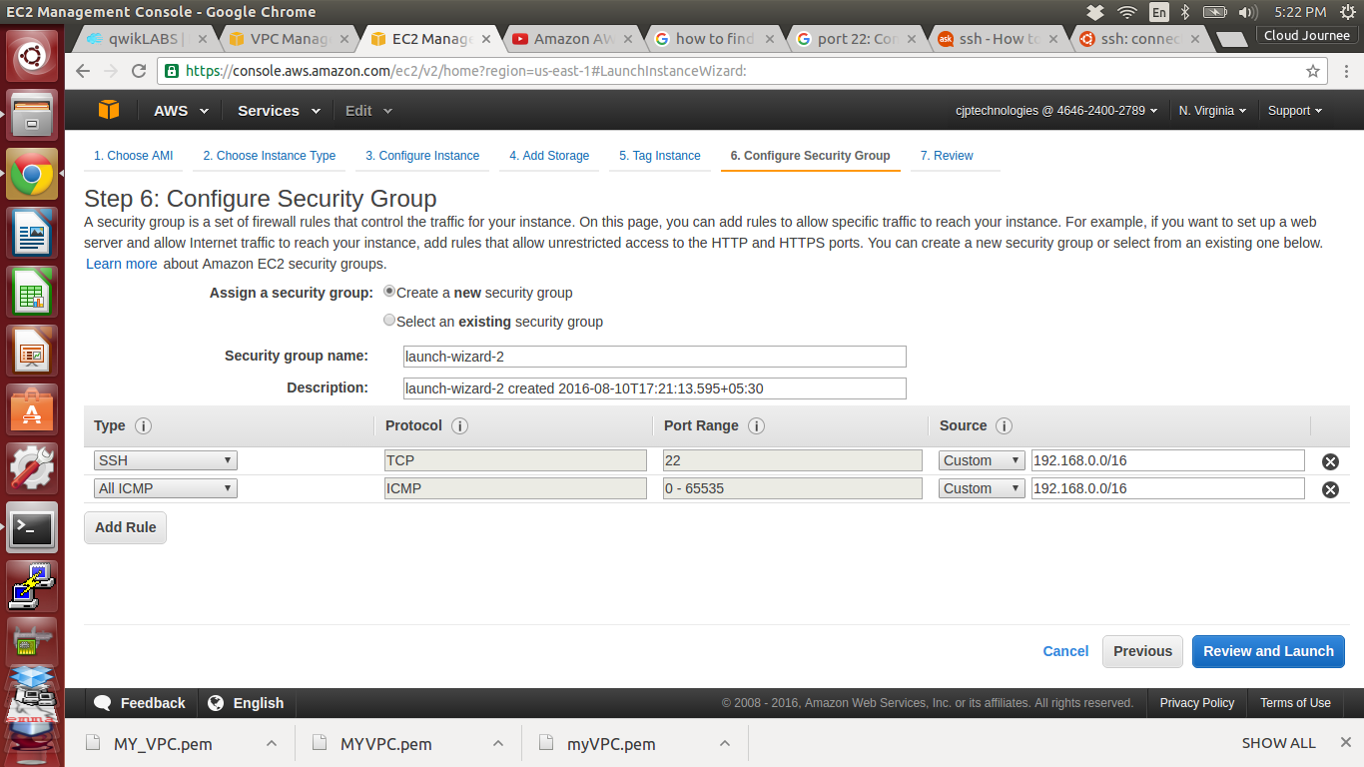

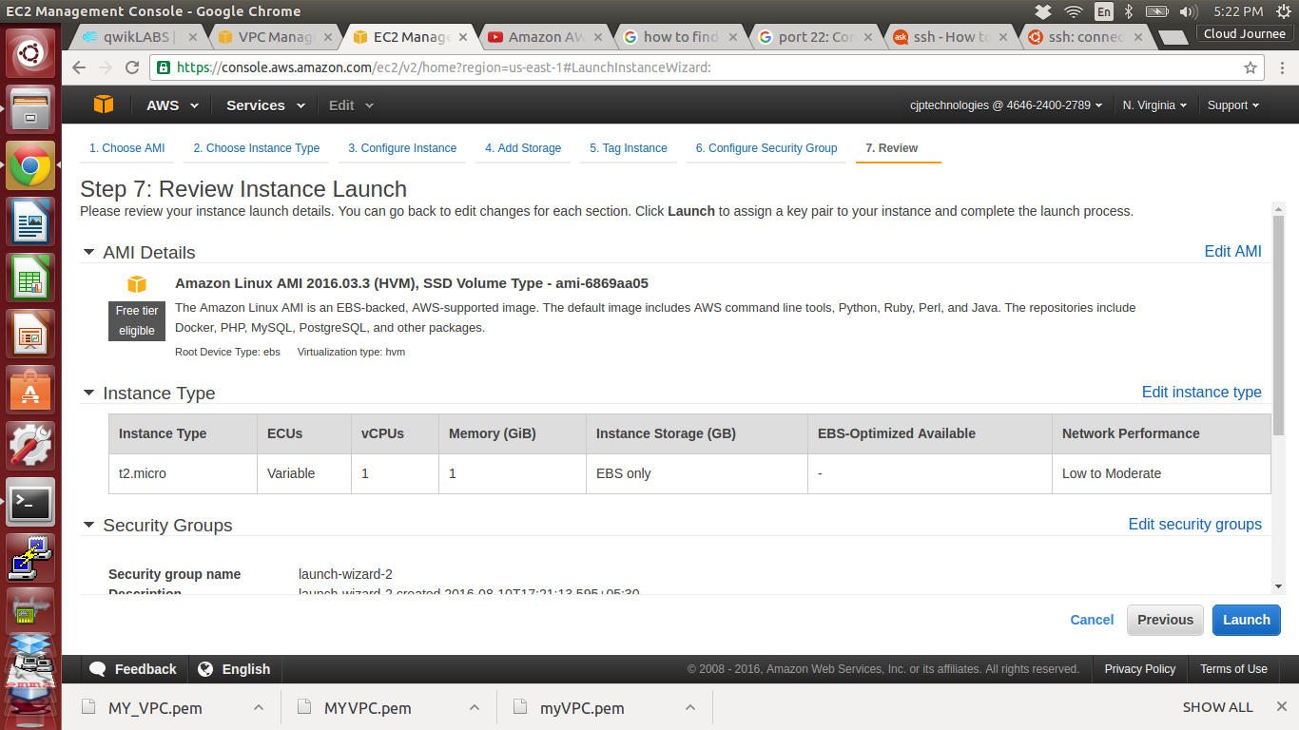

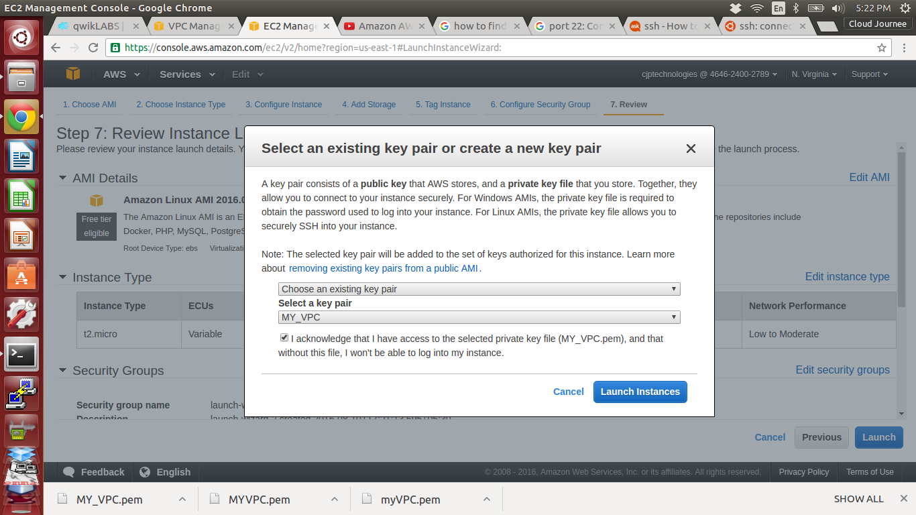

54. PRIVATE instance created

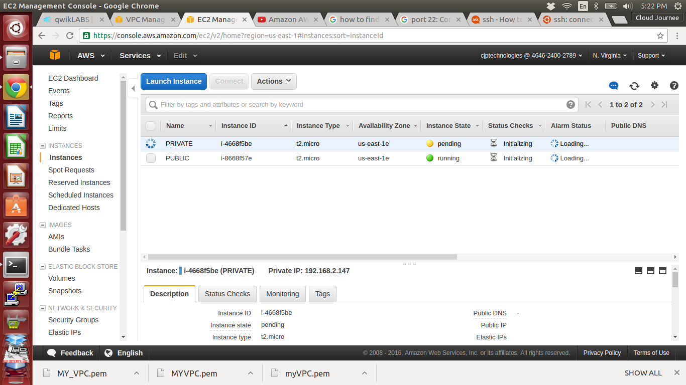

55. Open Terminal from our system and give permission for downloaded Key pair

***sudo chmod 400 MY_VPC.pem***

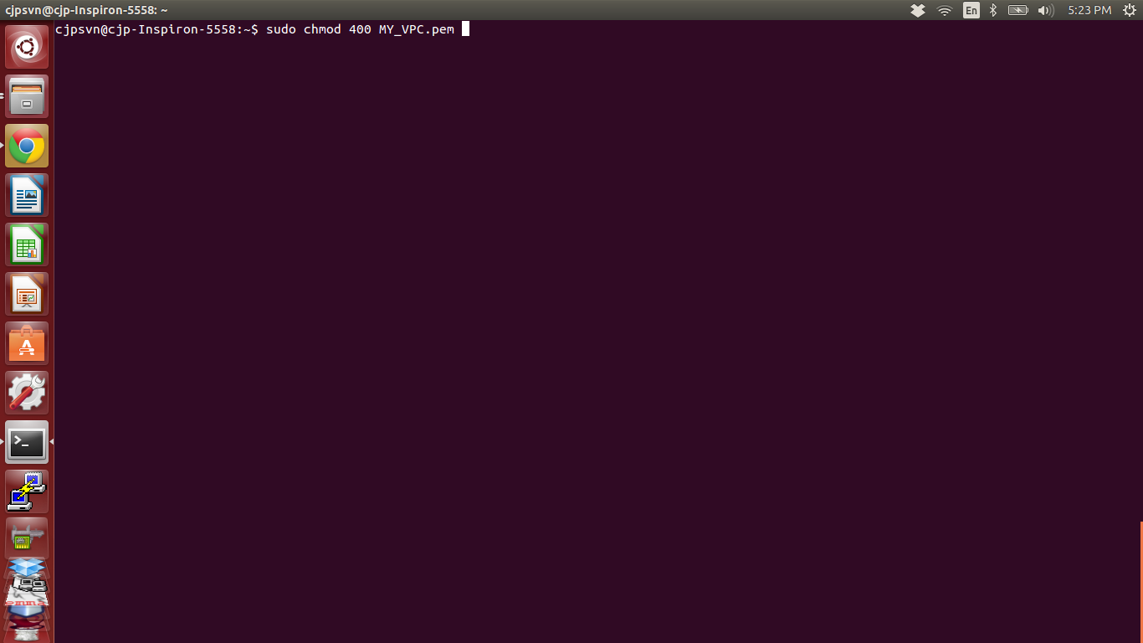

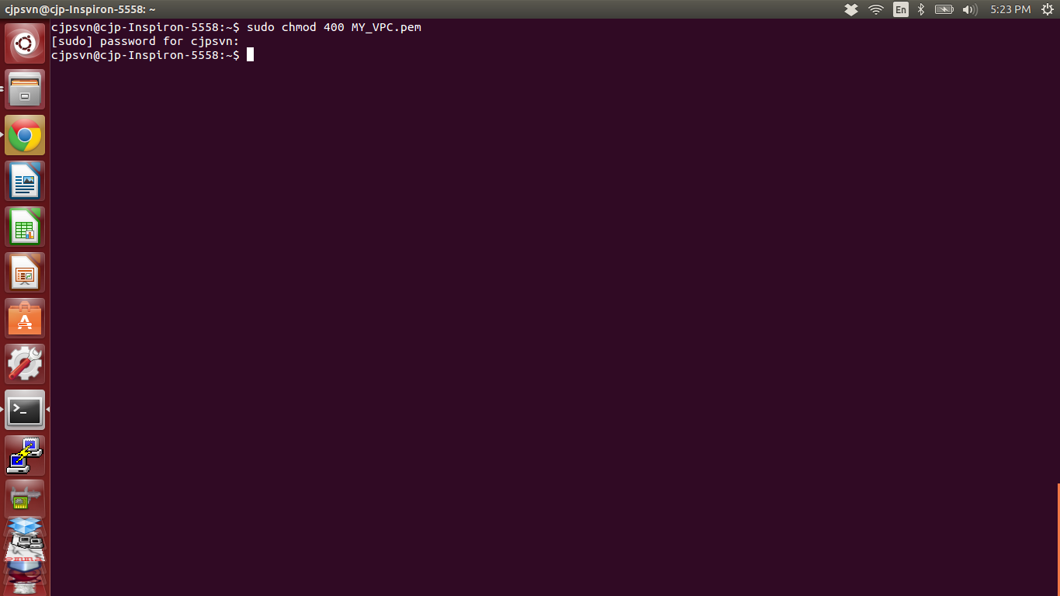

55. Open PUBLIC instance and Click Connect new window appear and select the line start

with ssh

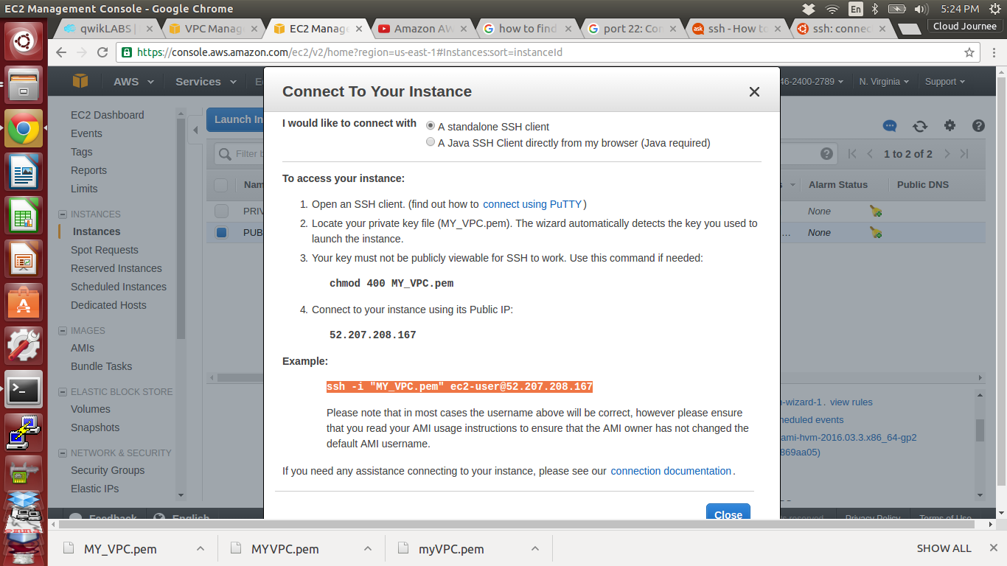

56. Paste the selected line to the terminal and enter

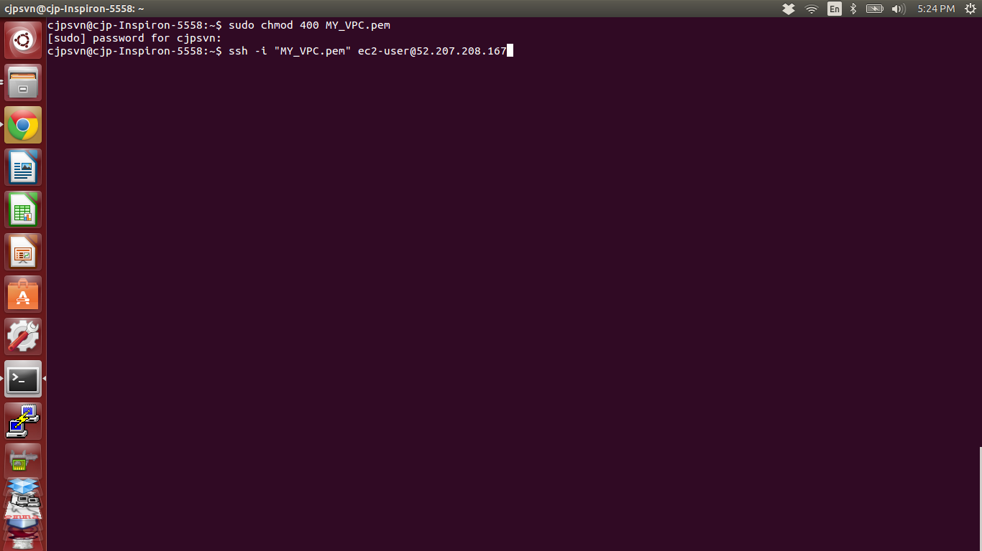

57. Type yes

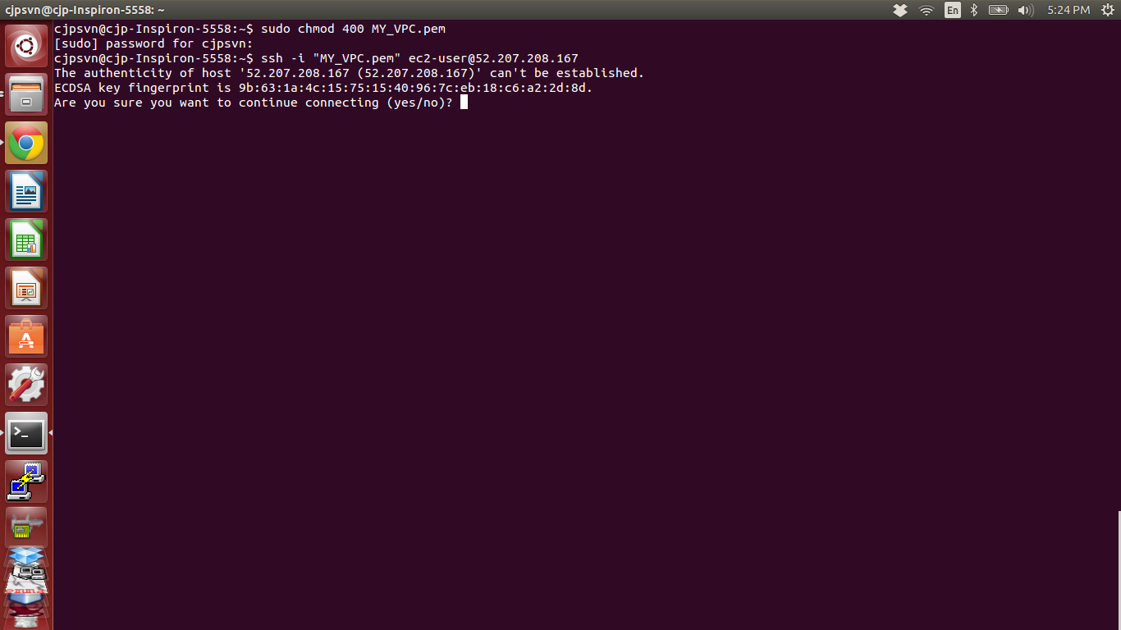

58. Now we are entered into the PUBLIC instance

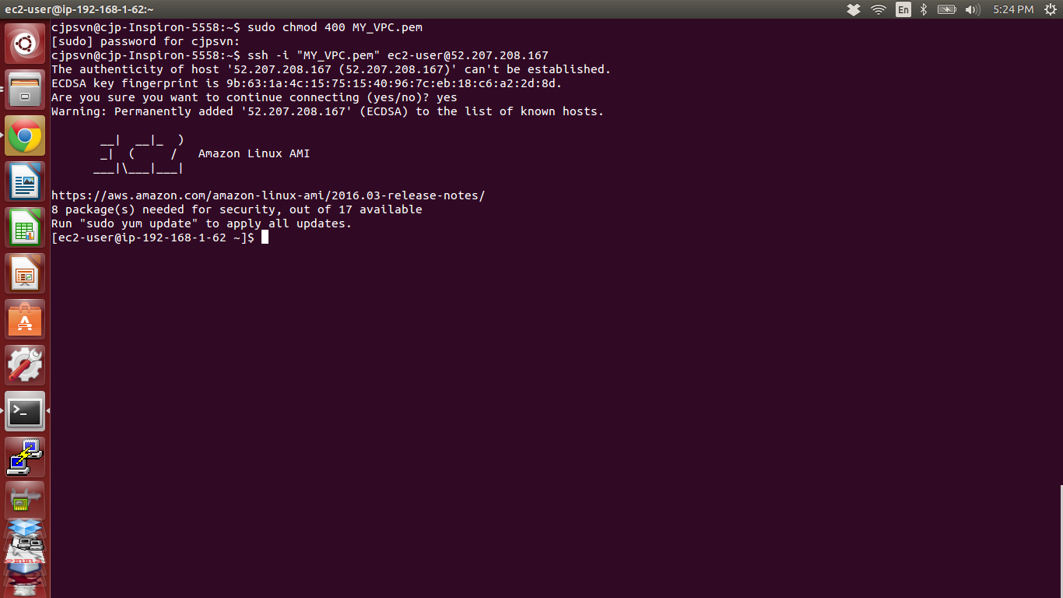

59. ping google for checking whether the instance connected to internet or not

***ping google.com***

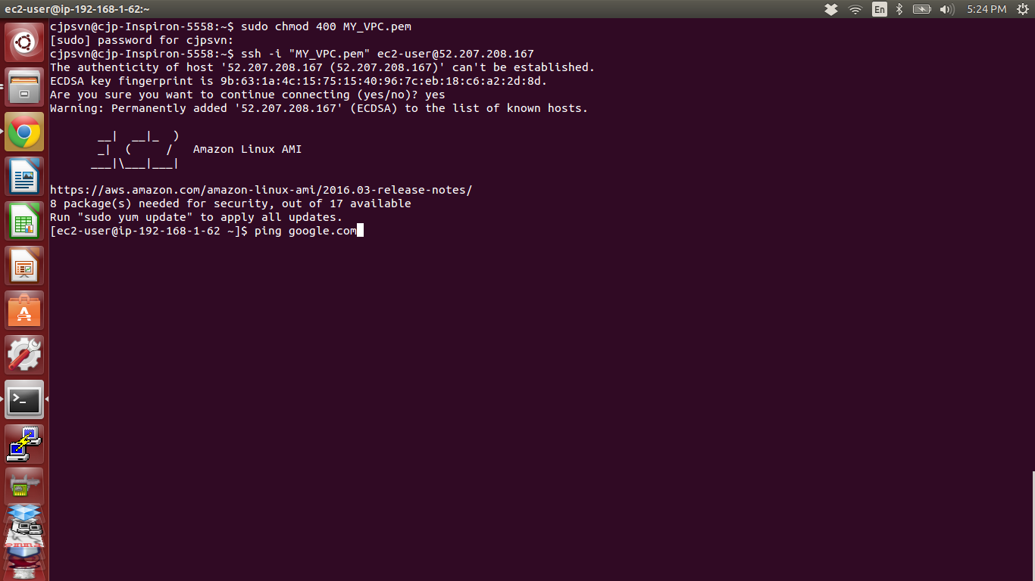

60. Yes the connection is 100% successful we can access internet in PUBLIC instance

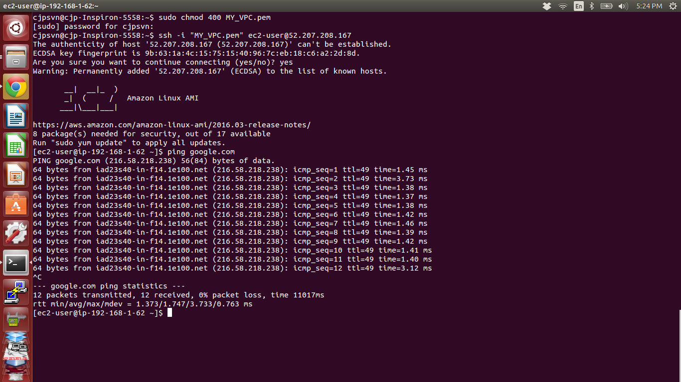

61. Copy the PRIVATE instance Private IP

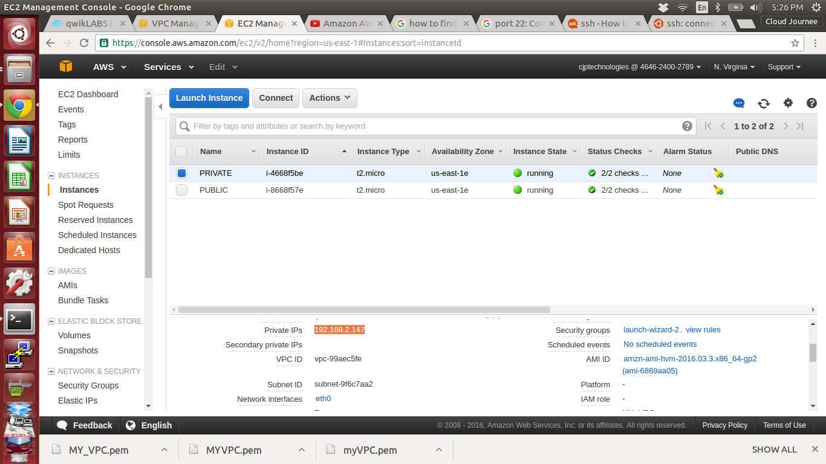

62. Ping the PRIVATE instance private IP from PUBLIC instance for Checking Connection

between both PUBLIC and PRIVATE instance.

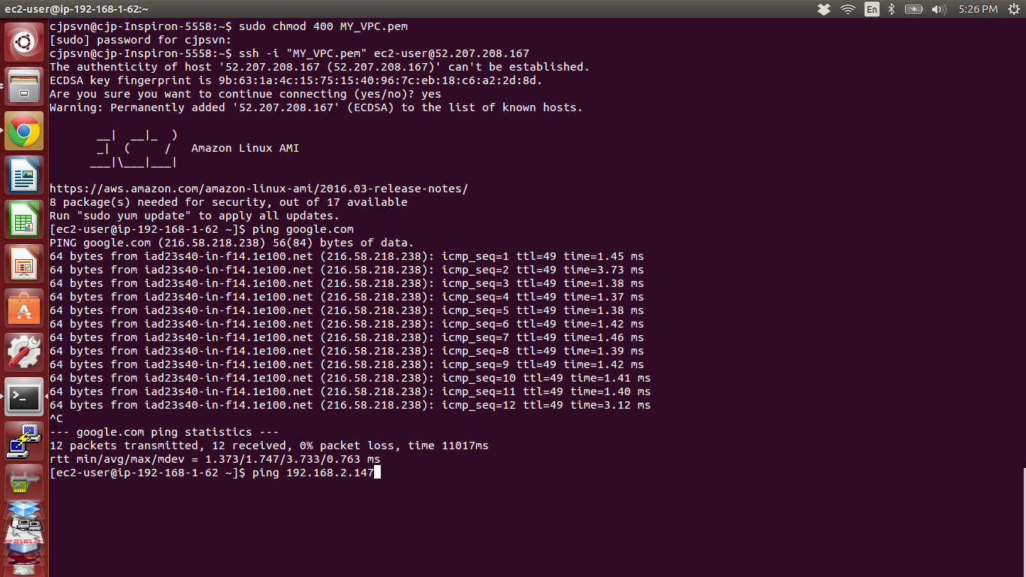

63. Connection Successful PUBLIC instance can connect PRIVATE instance ( Because it's in

same VPC, and every Subnet has interconnection with other subnet which present in same

VPC)

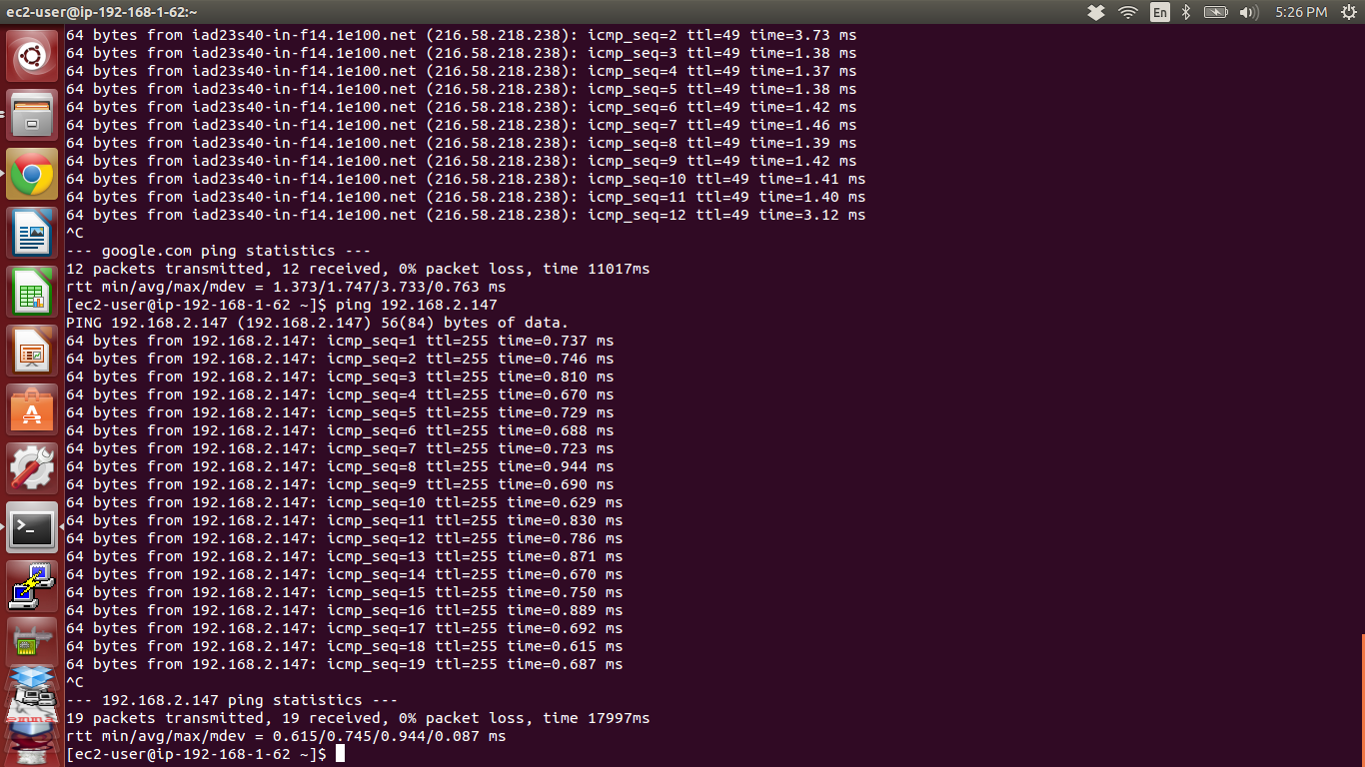

64. Let's try the PRIVATE instance to connect from our system terminal like same way we did for PUBLIC instance

* It won't connect because it has no permission to access internet gateway

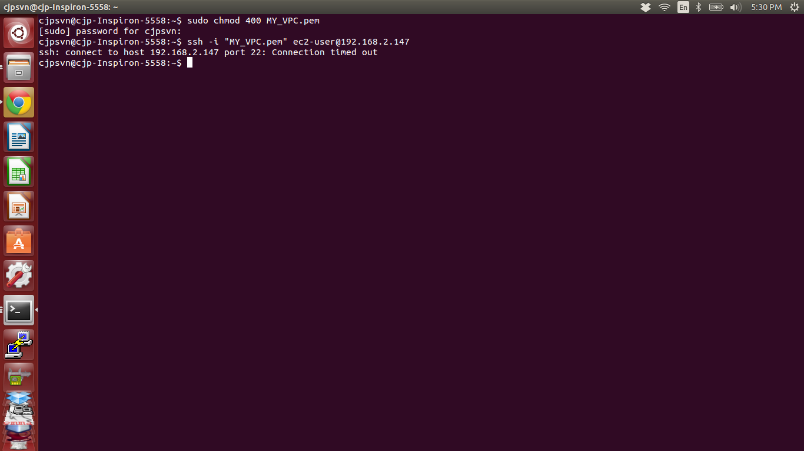

65. We can Connect PRIVATE instance through only PUBLIC instance.

Steps are..

* Copy “MY_VPC.pem” key file to PUBLIC instance from system terminal.

***sudo scp -i “MY_VPC.pem” MY_VPC.pem ssh -i “MY_VPC.pem” ec2-user@52.207.208.167:~/.***

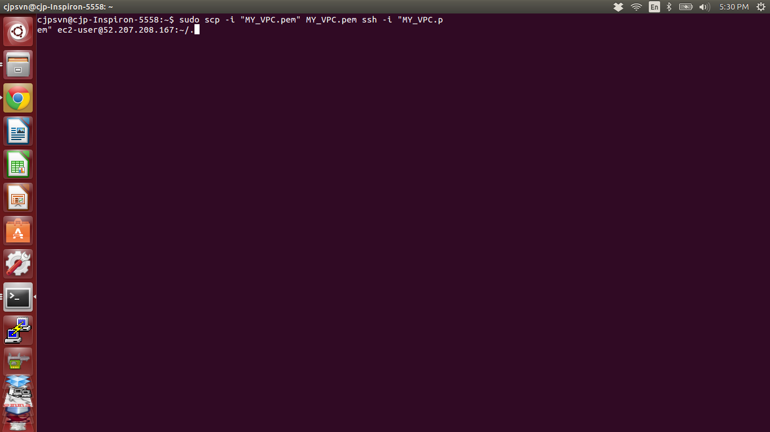

65. Copied successfuly

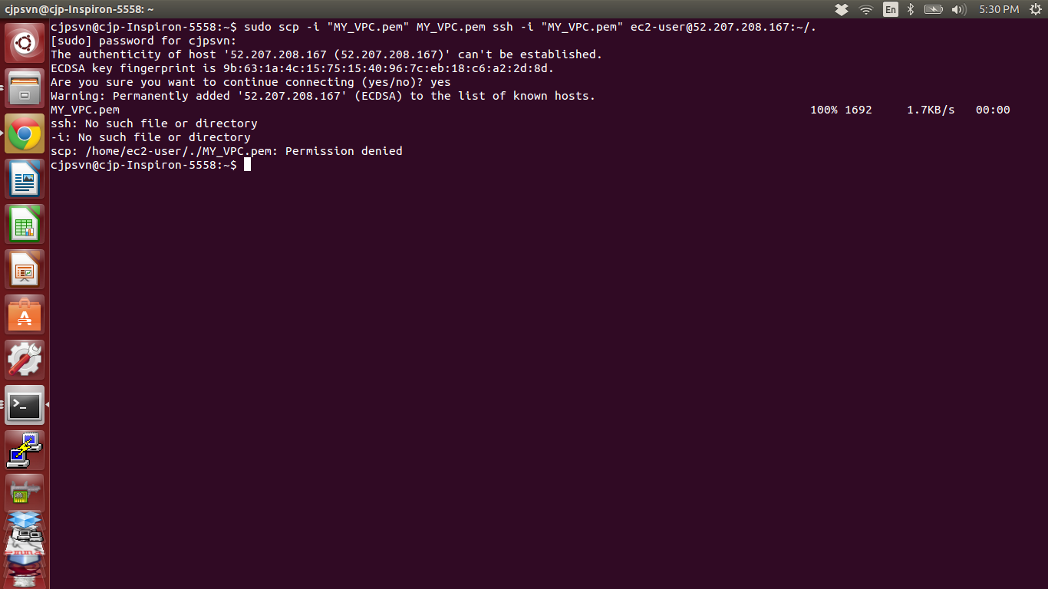

66. Can view file through ls command

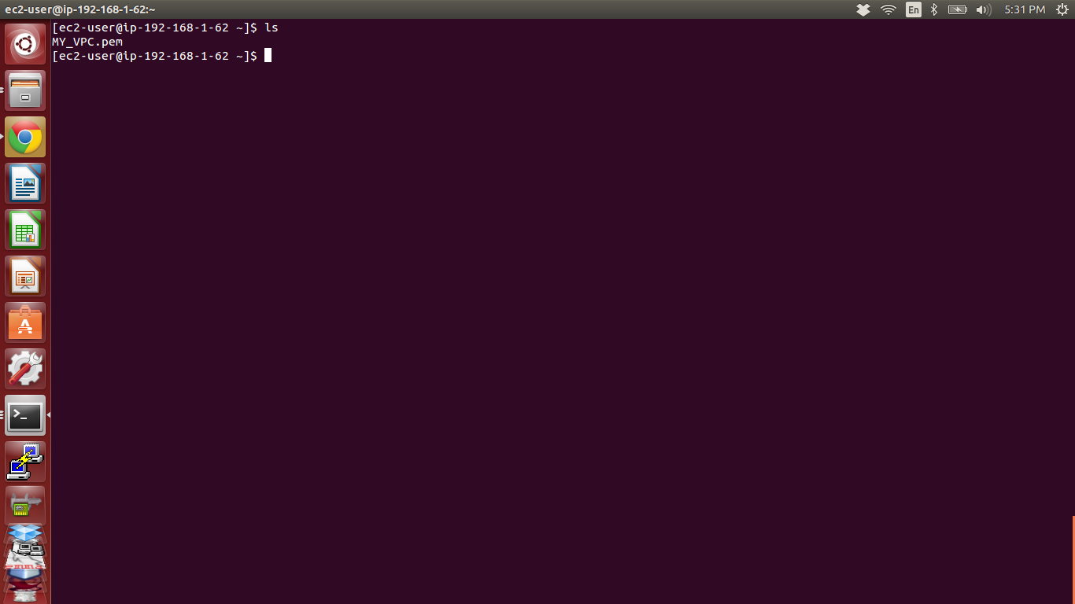

67. move the pem file to home directory

***sudo mv MY_VPC.pem***

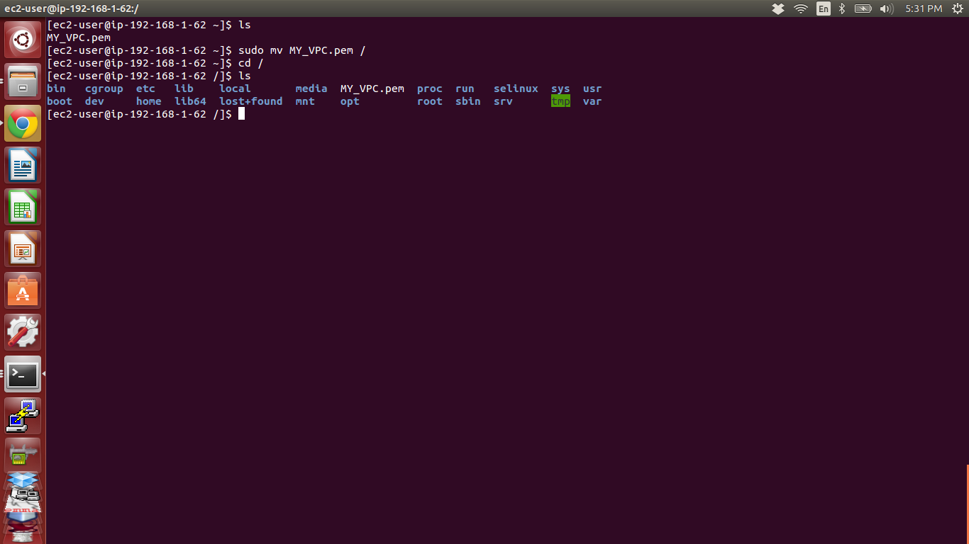

68. Give permission to pem key

***sudo chmod 400 /MY_VPC.pem***

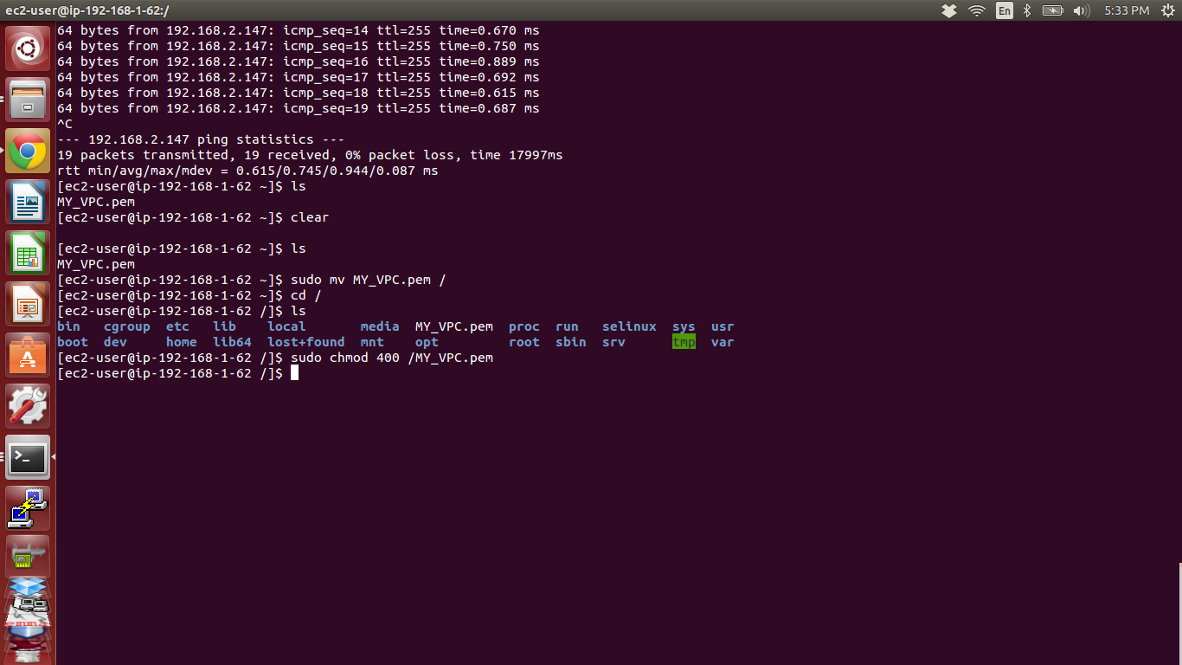

69. Copy the PRIVATE instance address

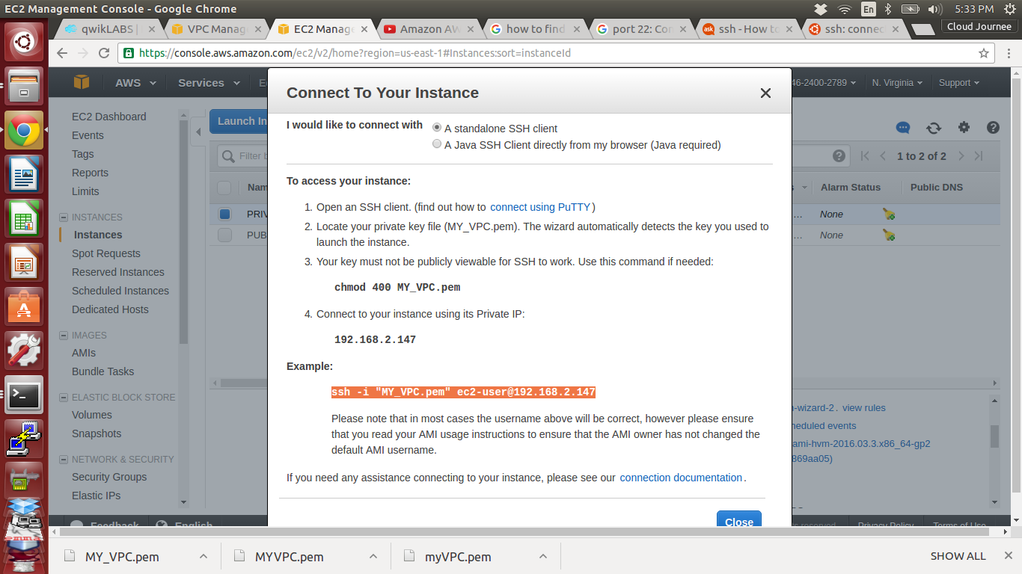

70. Paste it and enter

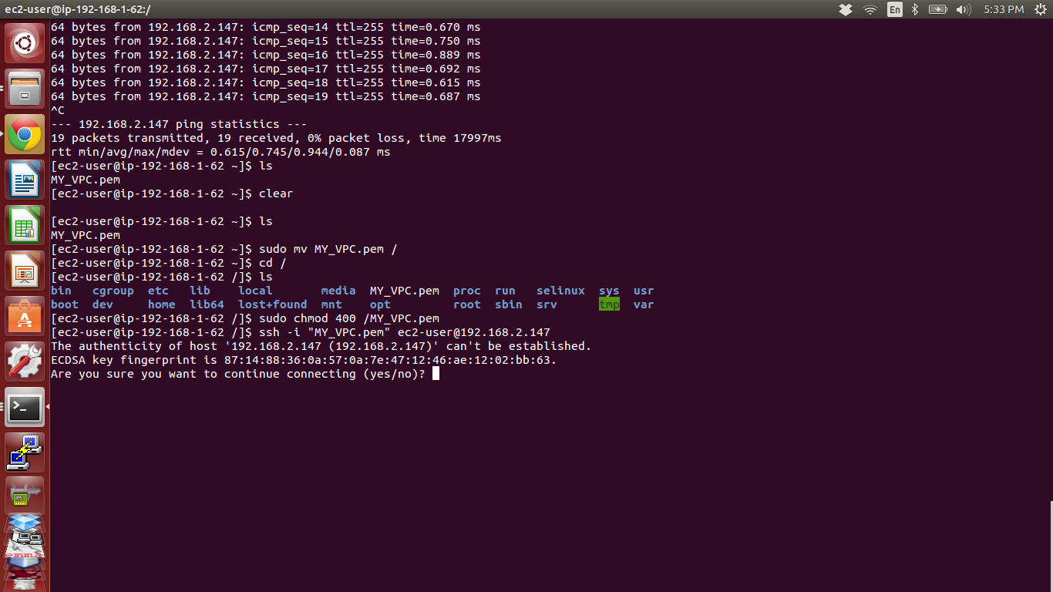

71. Done PRIVATE instance is connected inside the PUBLIC instance now we can view the

files of PRIVATE instance

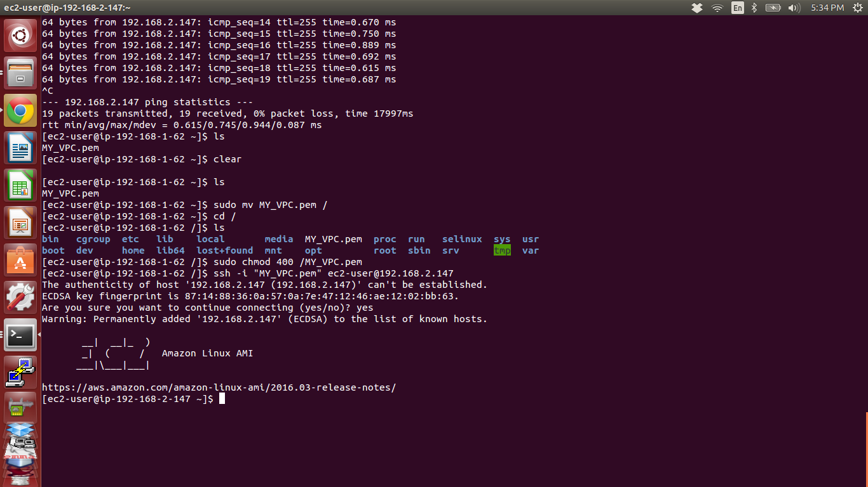

72. But still we can't ping google

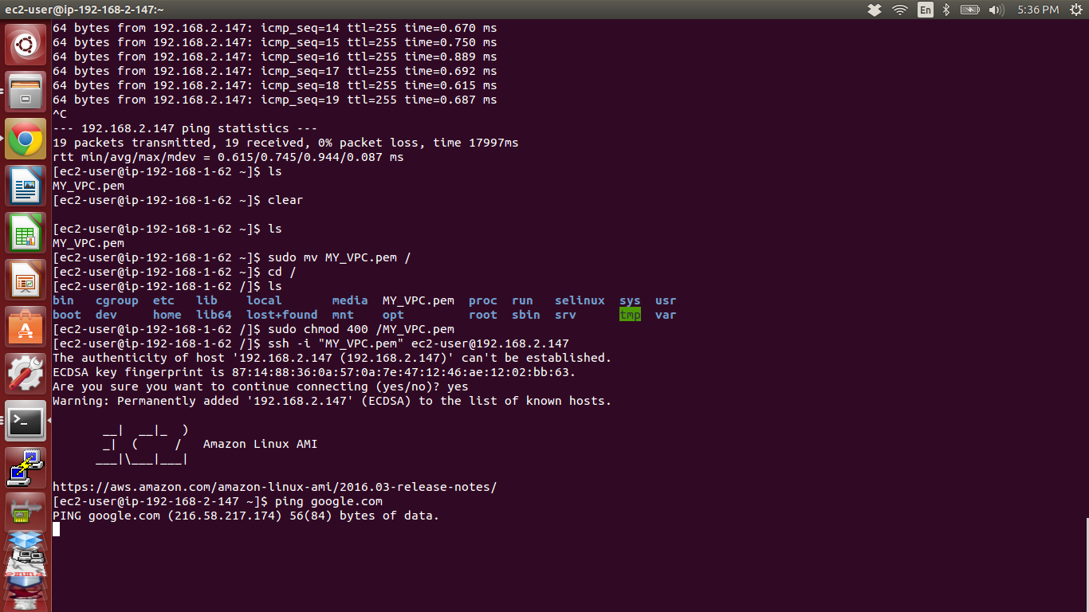

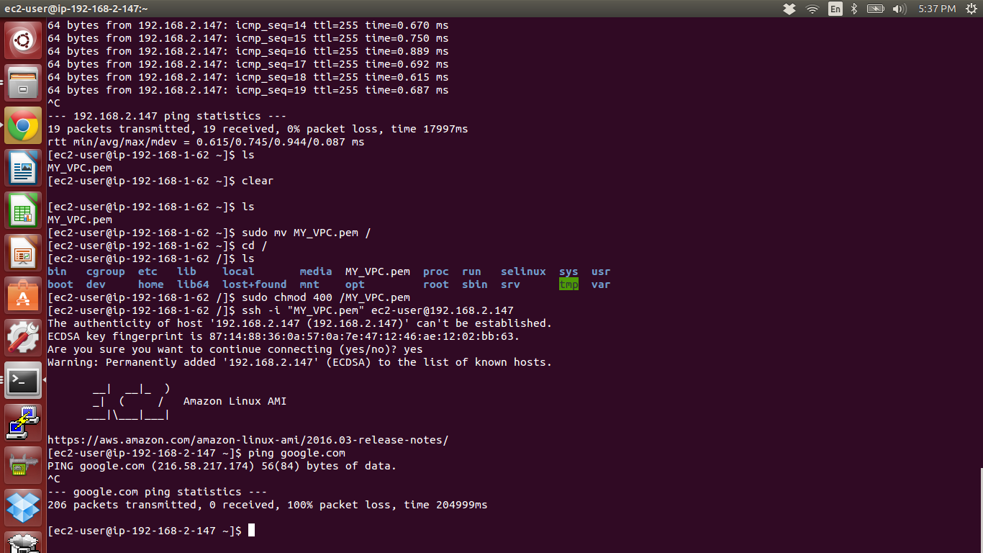

73. But we can ping PUBLIC instance from PRIVATE instance

Copy the Private IP of PUBLIC instance

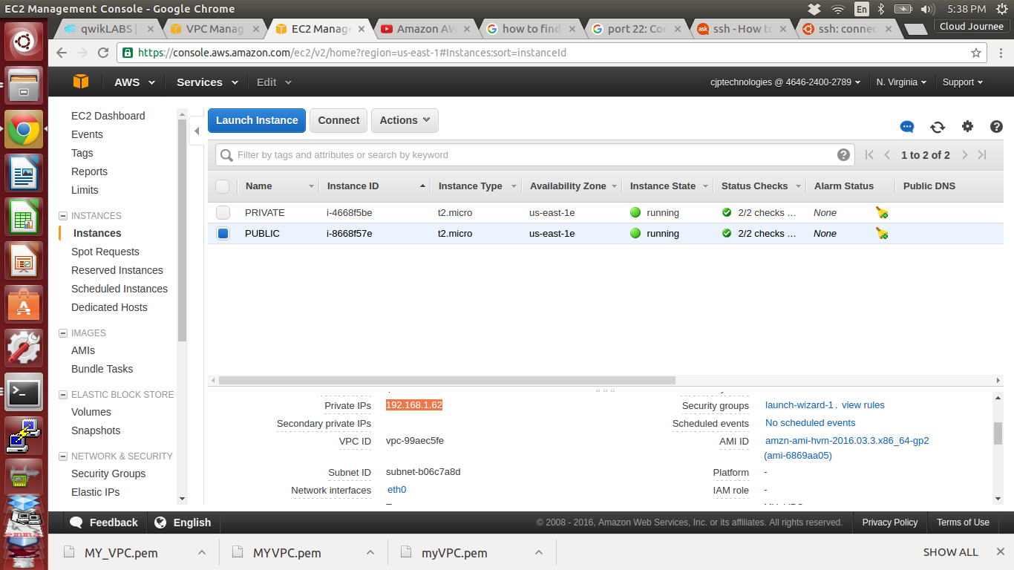

74. ***ping 192.168.1.62***

